## Left - assignment -3 -> validate date obj

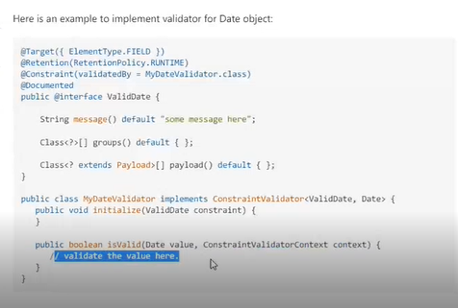

# 18th nov

## Databases

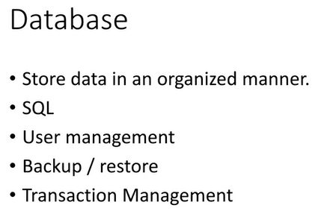

Diff types of databases

1. RDBMS

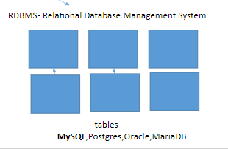

Data will be managed in the form of tables

1. Document based

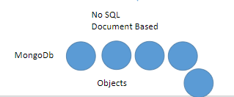

Data will be stored in the bases of objects

## 2. MySQL

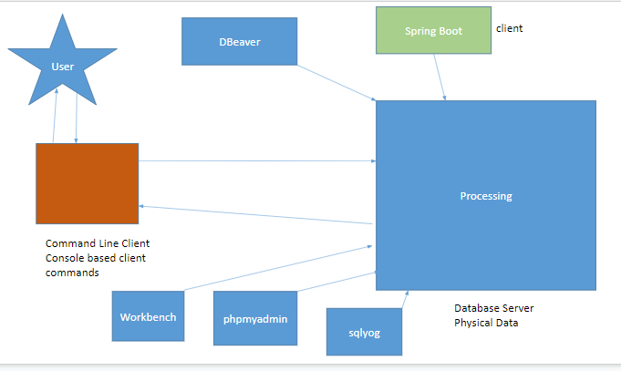

Database server - stores the physical data

Prb -> we cannot directly communicate with the Db server

So instead of writing commands every time we have easier option - GUI - there r a lot of options available

Apart from this our spring boot will also be directly connected with the database server

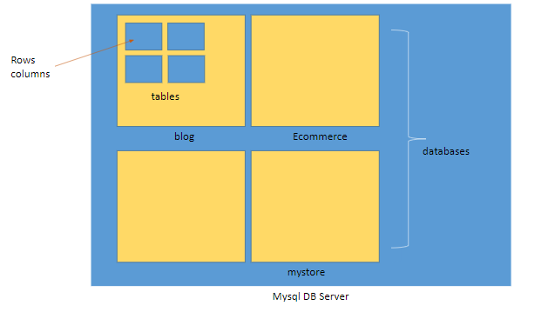

Internal working of db server

## Command line commands

1. 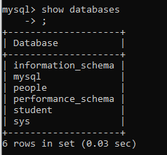
2. 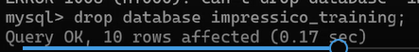
3. 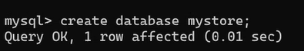
4. 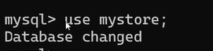
5. 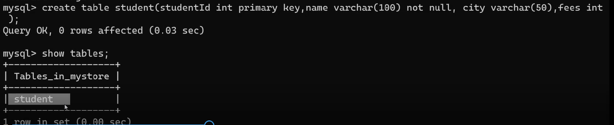
6. 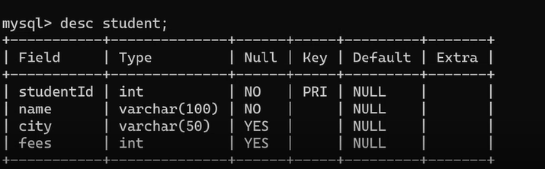
7. 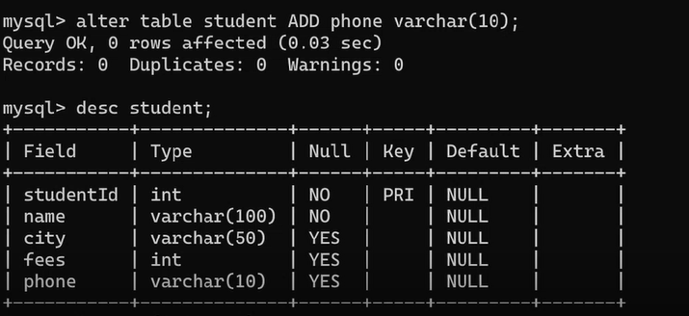
8. 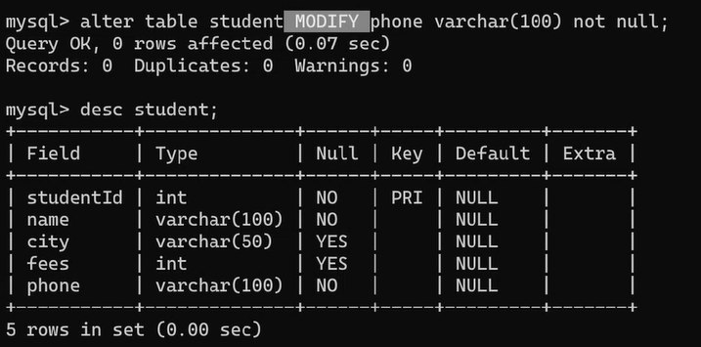
9. 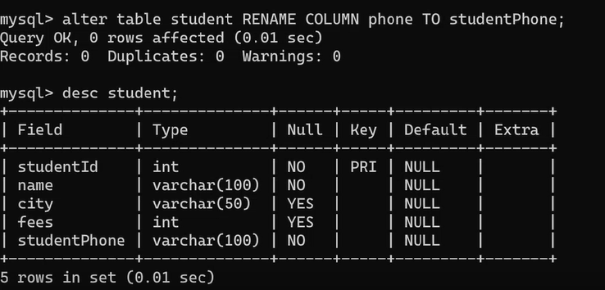
10. 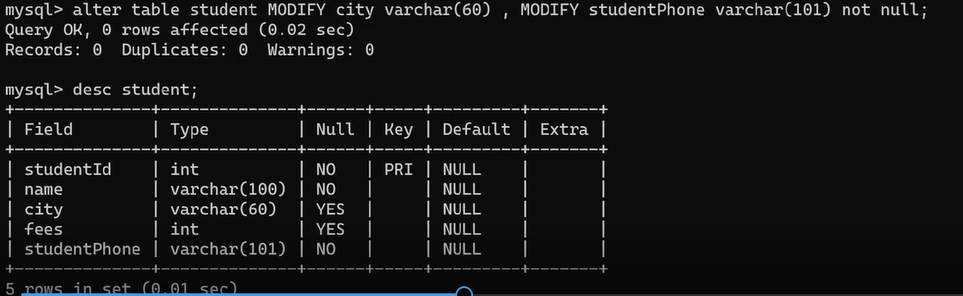
11. 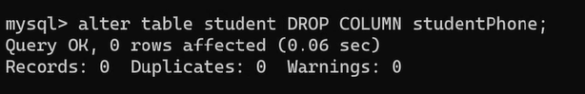
12. Cant add a column to a table after it already has some data in it. Either have it as not null or define a default value.
13. 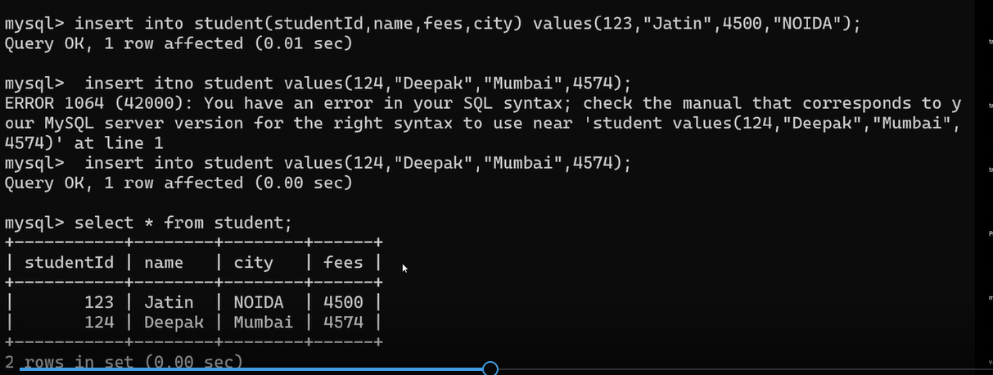
14. 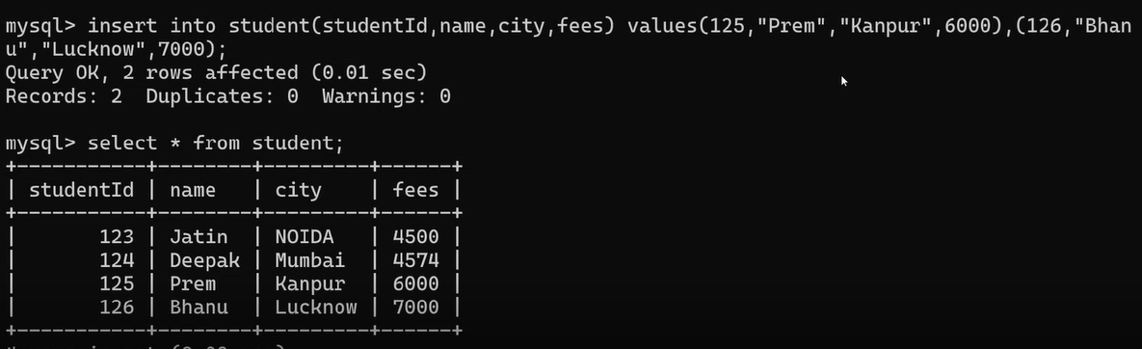
15. 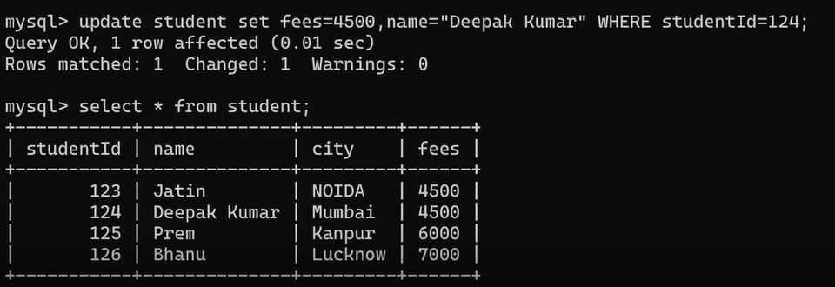
16. 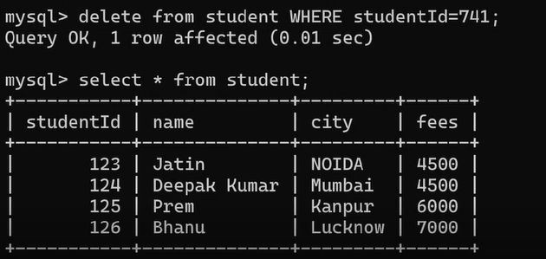
17. 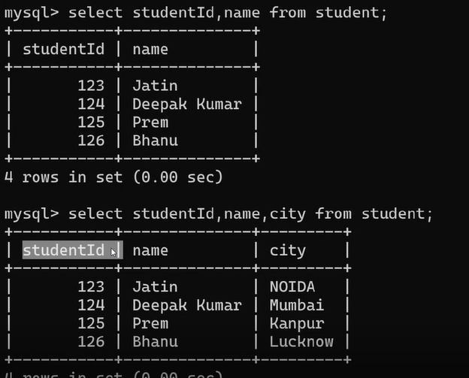
18. 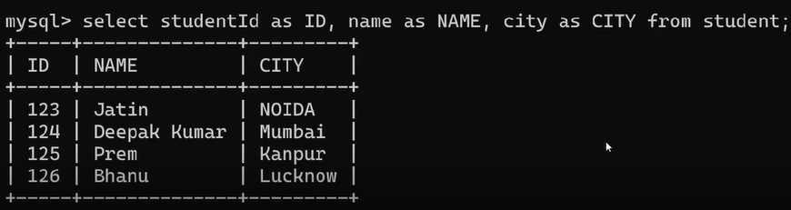
19. 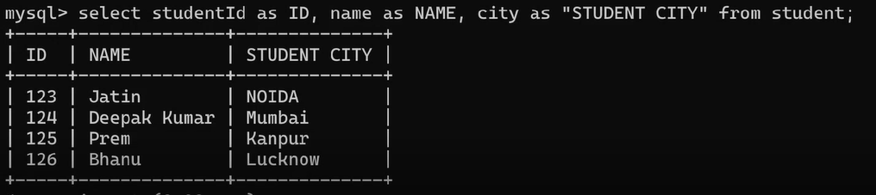
20. 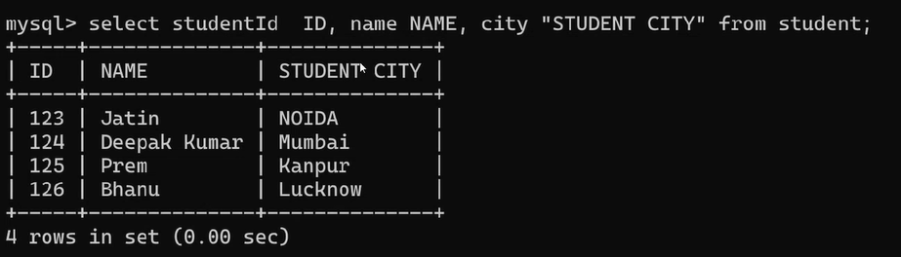
21. 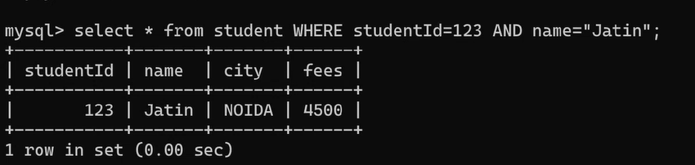
22. 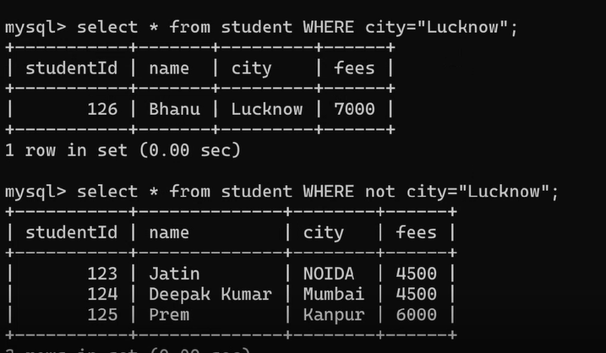
23. 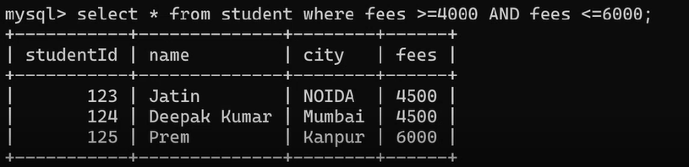
24. 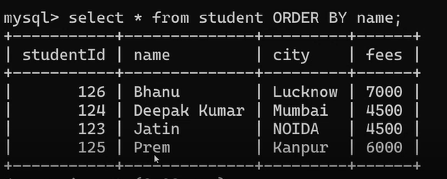
25. 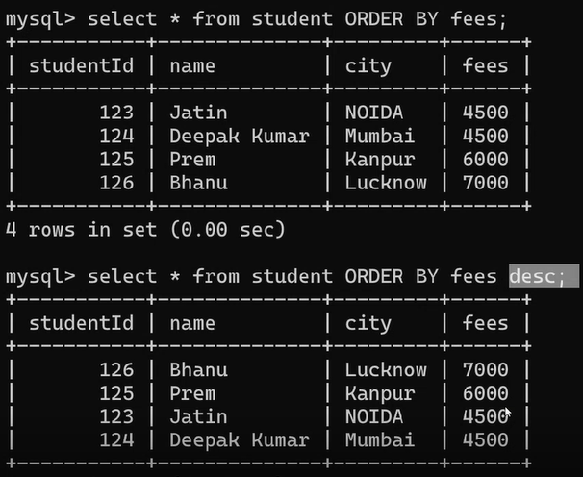
26. 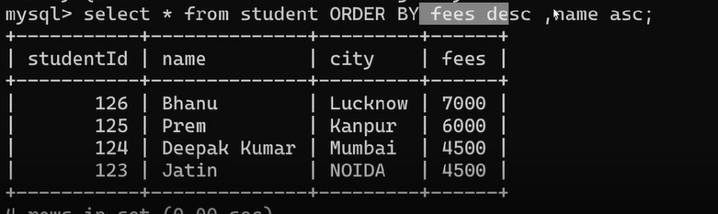

# 21st nov

## MySQL commands

1. 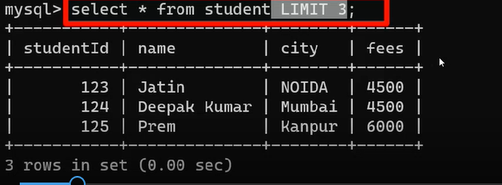
2. 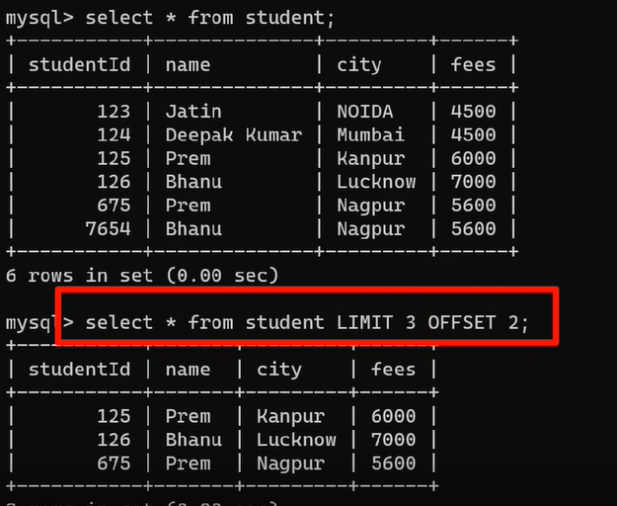
3. Pagination -> we need diff data in diff pages. Basically using limit and offset
4. 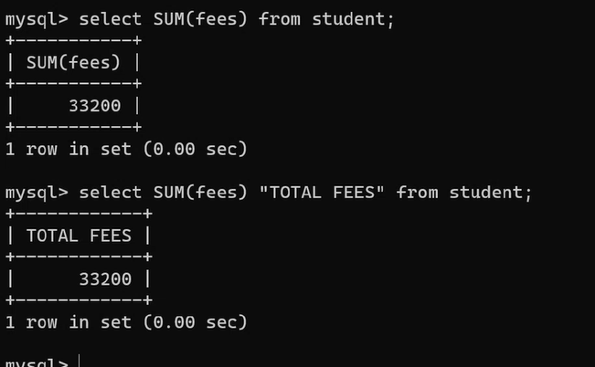
5. 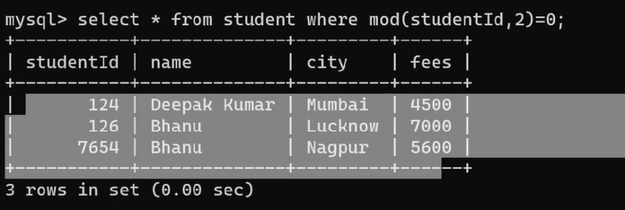
6. Selecting alternate records 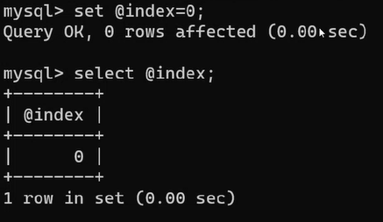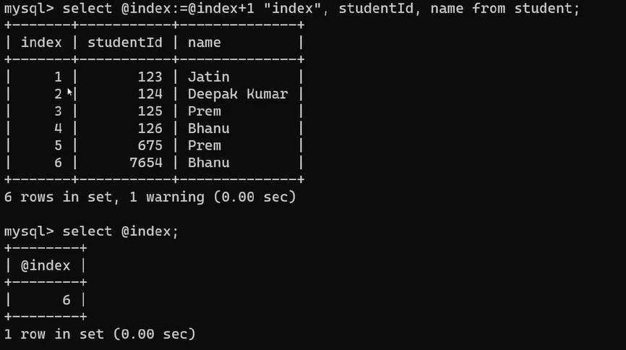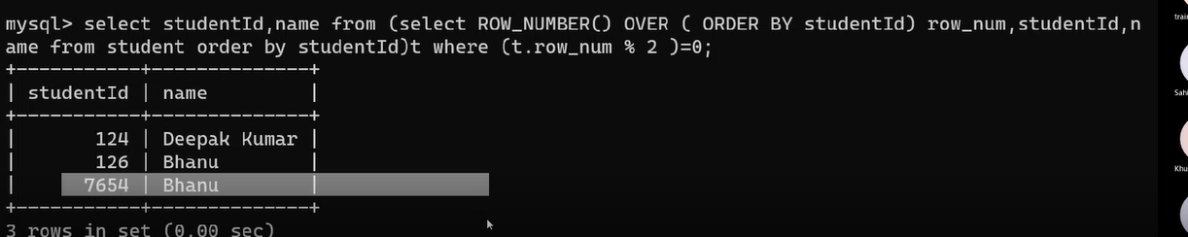

So basically this is generating a table which we denoted as t



1. 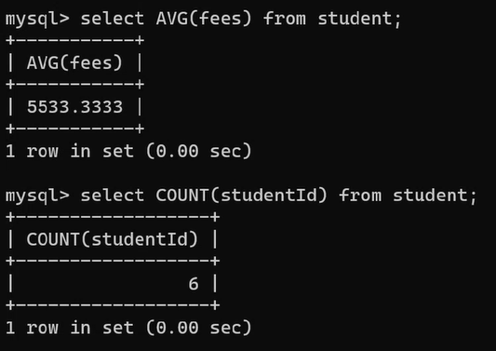
2. 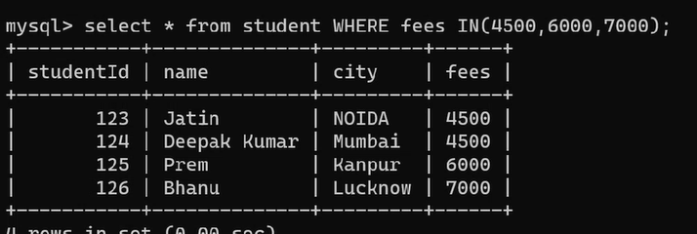
3. Upper and lower range r included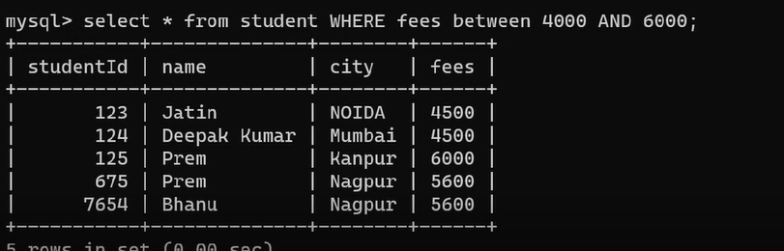
4. Like operator - pattern

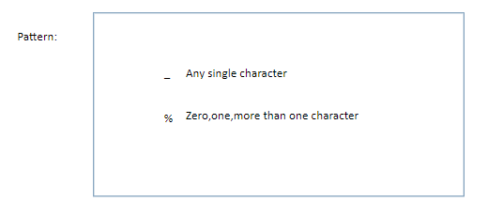

Name starting with p -> % as there can be multiple characters after that

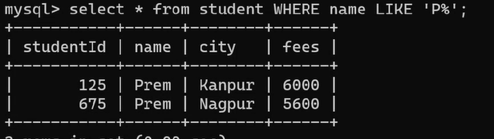

Name starting with p and ending with m

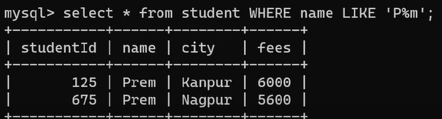

2nd letter is h->

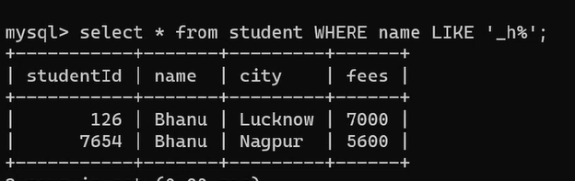

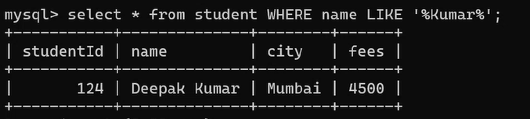

## 2. JOIN

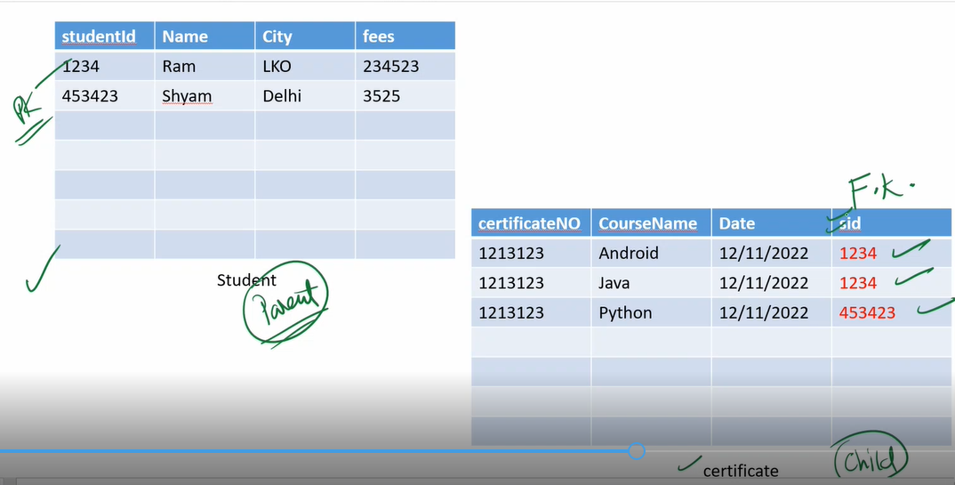

Cascade

CASCADE in SQL is **used to simultaneously delete or update an entry from both the child and parent table**. The keyword CASCADE is used as a conjunction while writing the query of ON DELETE or ON UPDATE.

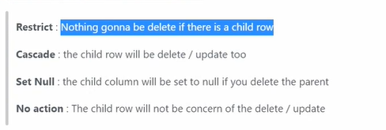

# 22nd nov

## JOIN

Table - student, certificate

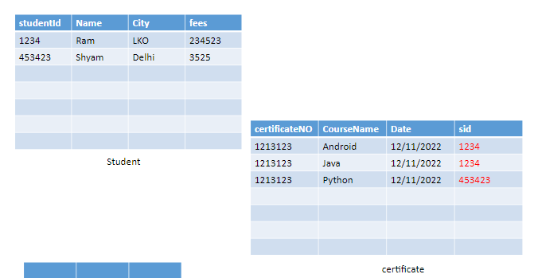



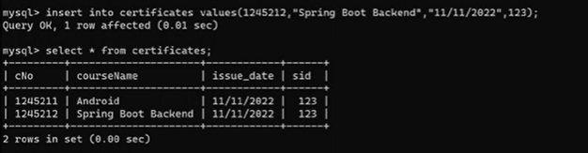

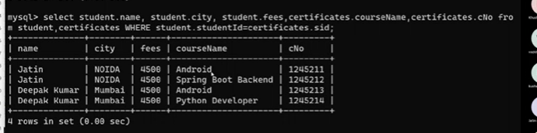

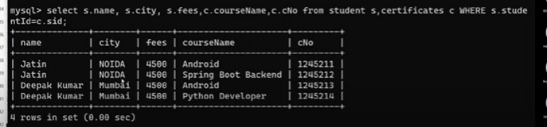

## User and privileges

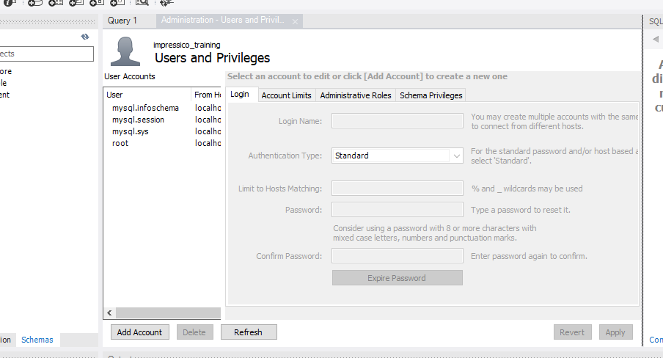

## Reverse engineering

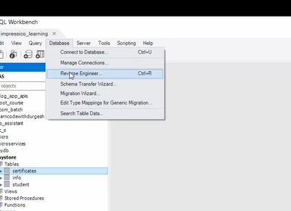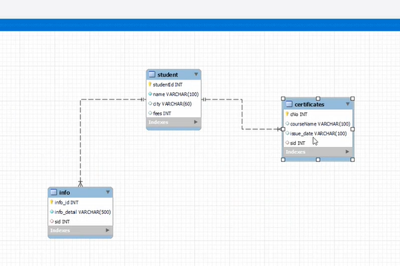

## Connecting springboot with database

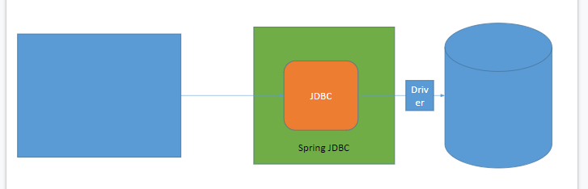

Two ways

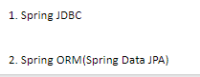

## Spring jdbc

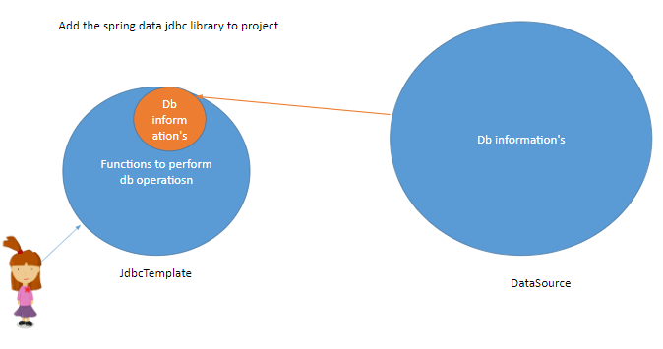

Steps ->

1. Dependency

<!-- https://mvnrepository.com/artifact/org.springframework.boot/spring-boot-starter-jdbc -->

<dependency>

<groupId>org.springframework.boot</groupId>

<artifactId>spring-boot-starter-jdbc</artifactId>

<version>3.0.0</version>

</dependency>

1. Driver

<!-- https://mvnrepository.com/artifact/com.mysql/mysql-connector-j -->

<dependency>

<groupId>com.mysql</groupId>

<artifactId>mysql-connector-j</artifactId>

<version>8.0.31</version>

</dependency>

1. Database info - app.properties file

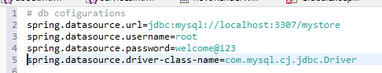

Spring boot - autoconfig

Jdbctemplate would be a bean that would be autowire

1. Make a file in repository

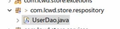

Make it @Repository

@Repository Annotation is **a specialization of @Component annotation which is used to indicate that the class provides the mechanism for storage, retrieval, update, delete and search operation on objects**.

Springboot -> did it on it own -> configure datasource, made jdbc template, injected datasource in jdbctemplate, made jdbc template as a bean

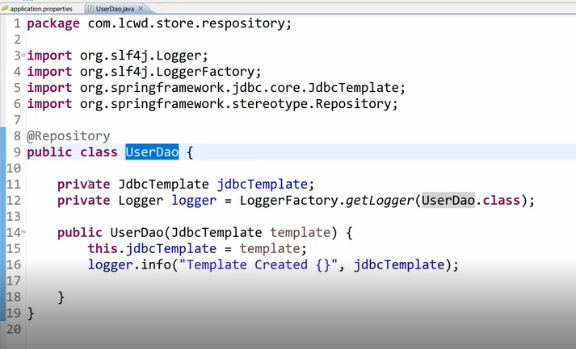

Here we havent used @autowired for jdbctemplate -> but as we have constructor -> it does constructor injection

1. Next we need to inject this userdao in main class

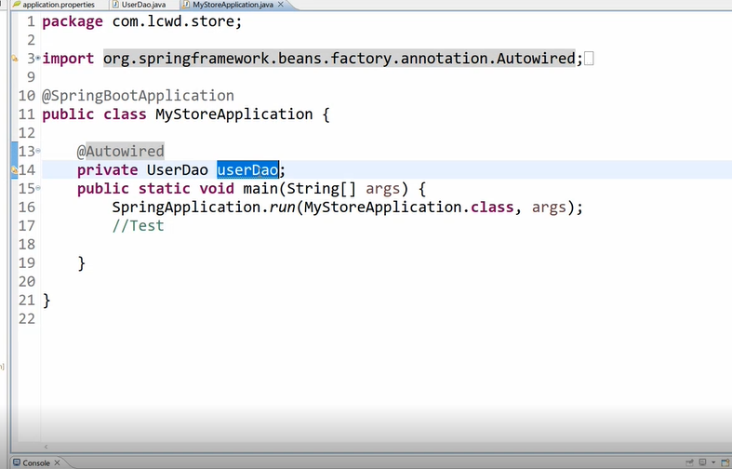

1. output->



1. Creating a table for user if it doesnt exist

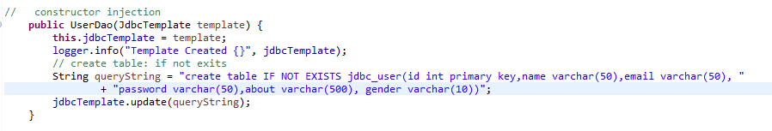

1. Create user

Dont take input from user like this -> can lead to sql injection

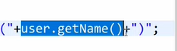

Instead use placeholders

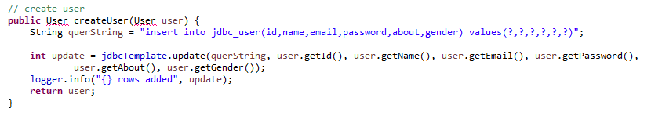

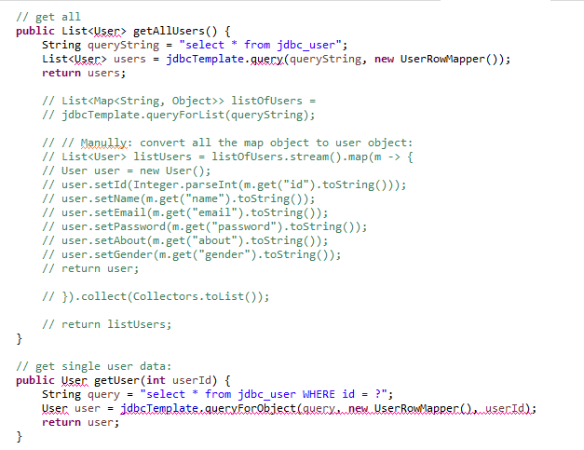

## 6. UserServiceJpaImpl

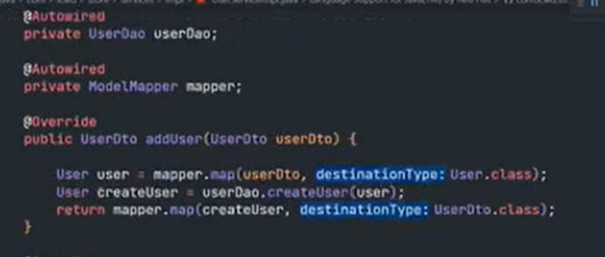

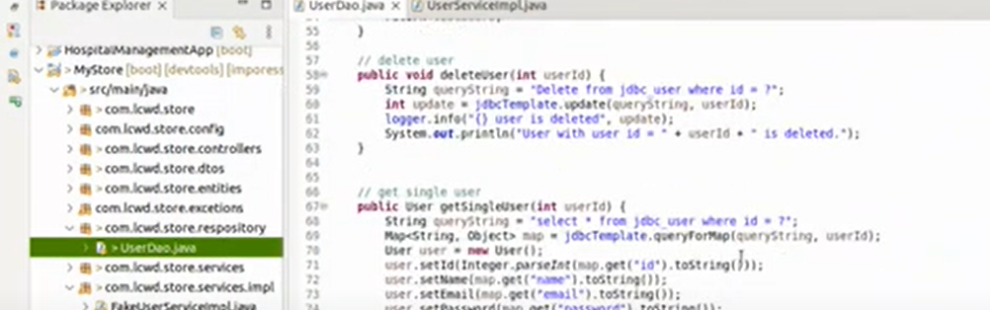

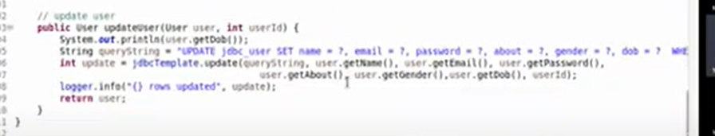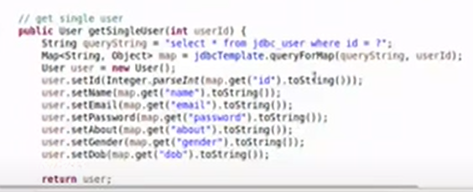

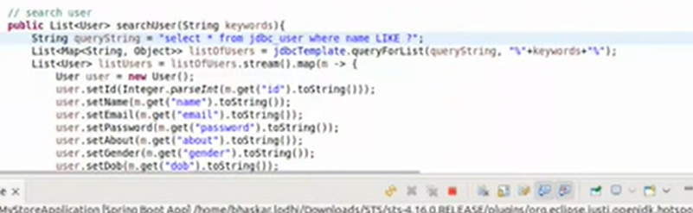

## 

# 23rd nov

## RowMapper

PRB ->

UserDao has database specific code which was done with jdbctemplate

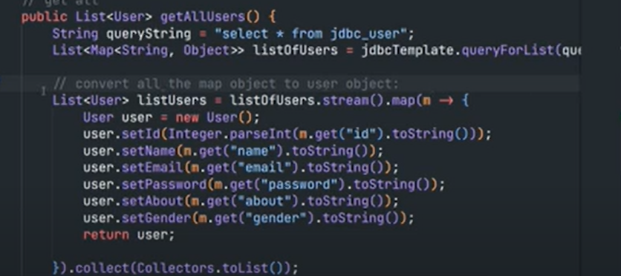

Here we had to Manully: convert all the map object to user object:

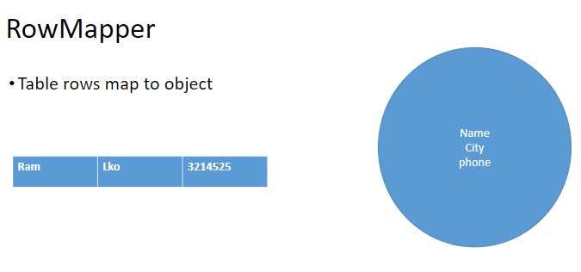

INSIDE UserDao file

Now instead of implementing methods as we were we will shorten it with the use of rowmapper

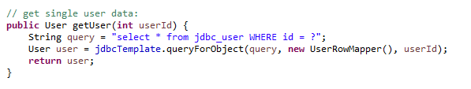

So we have to create a class UserRowMapper

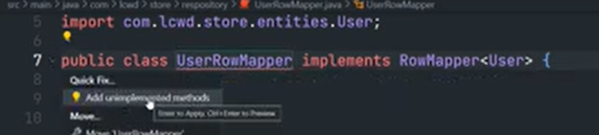

Add the unimplemented method gives us ->

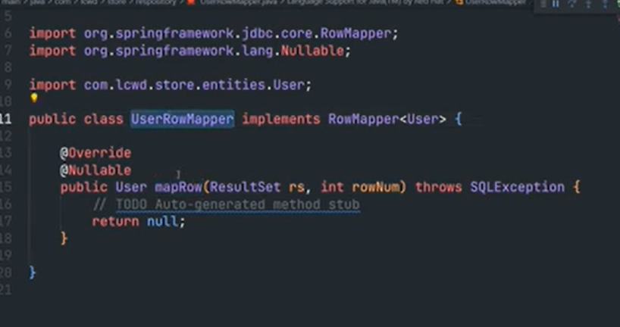

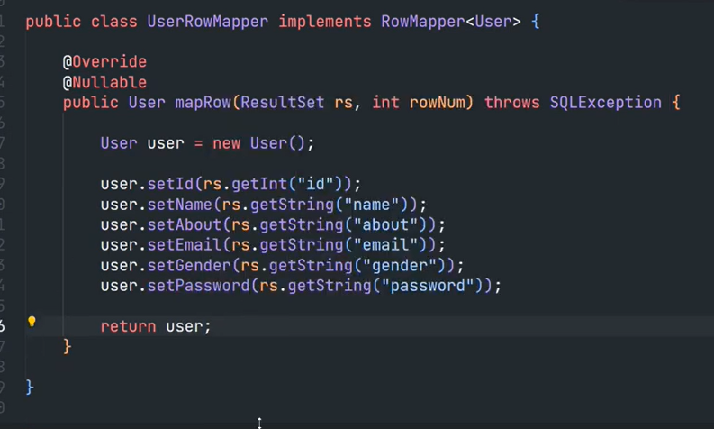

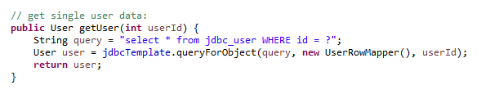

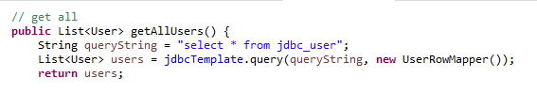

ROWMAPPER METHODS

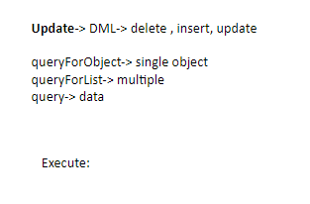

## Jdbc prbs

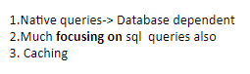

## ORM

Map object with table

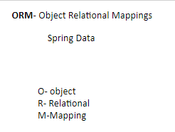

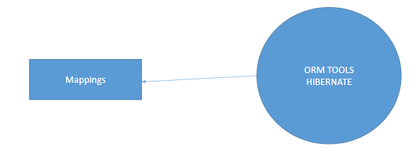

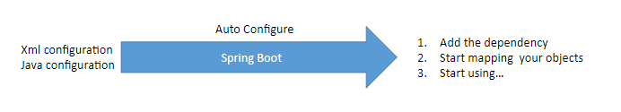

Mapping is a type of configuration

2 ways ->

Xml or java annotation

But in spring boot -> configuration on its own

### STEPS ->

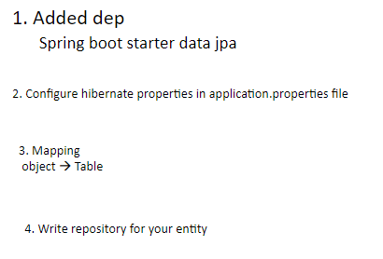

Step 2->

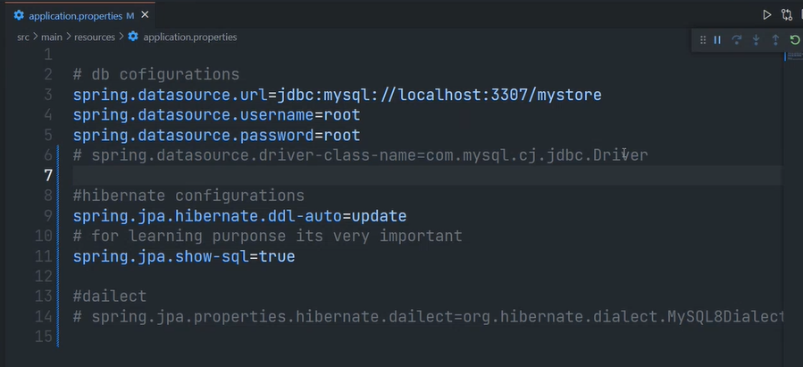

It will autocofnire the dialect and driver class from pox.xml dependencies

Incase it not able to do then we put it

Step3 -> User entity

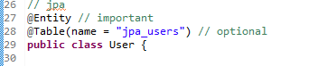

Making all the properties as columns (can be skipped)

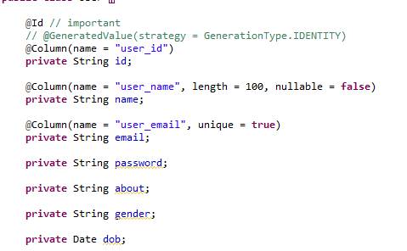

Step 4->

This repository will have all the functions



Jpa repository has all functions and we will just be using them in userepository

<class, datatype of id>

We dont have to give the implementation of these methods that also is given by jpa or spring

Step 5->

Create a service impl for jpa

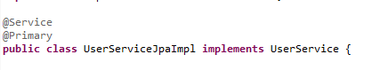

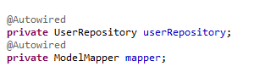

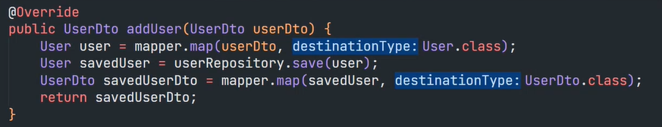

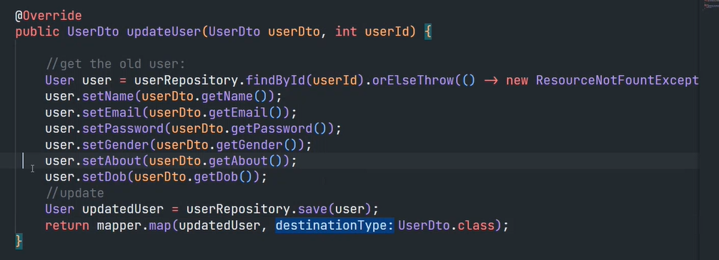

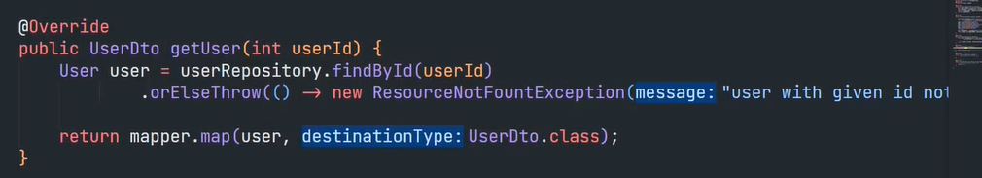

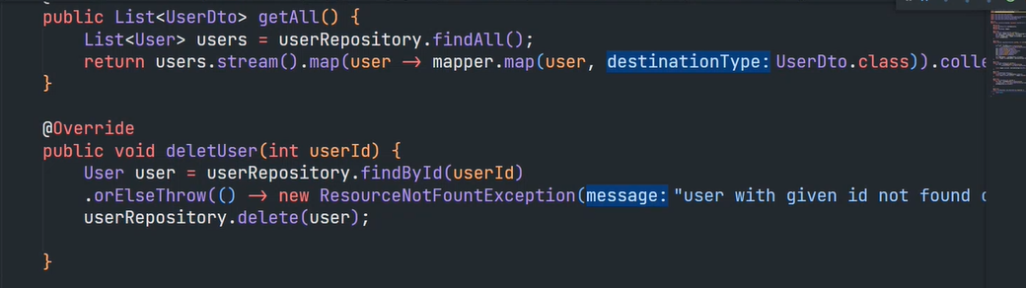

## ID - STRING

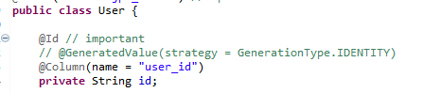

This no argument constructor will generate a unique id

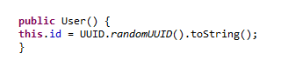

We will generate the id here

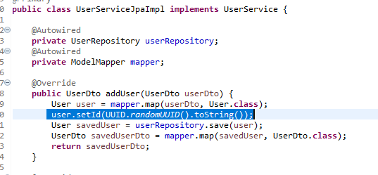

## Assignment -Left

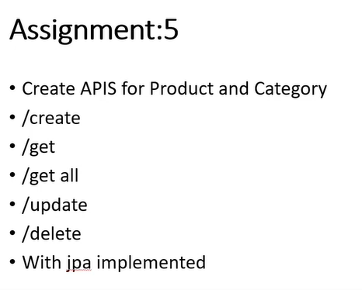

# 24th nov

## Custom finder methods

Implementing search user

These all methods should start with findBy…

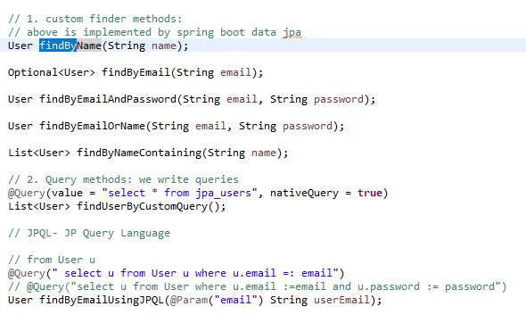

The impementation of all these methods will be handled by jpa itself cause we follwed the naming convention of method

We can have conditions for joining -> and / or

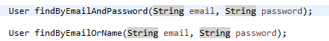

Also for like query ->



Some other queries -> google custom finder queries for spring boot

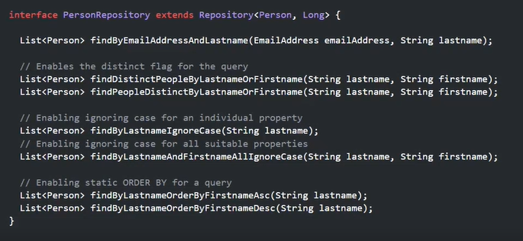

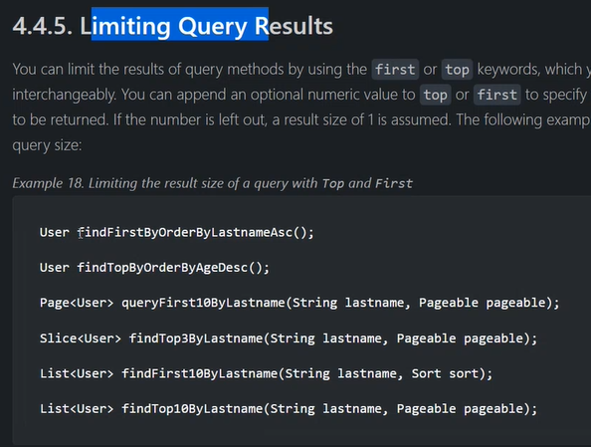

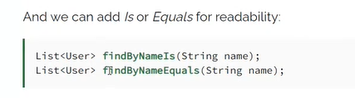

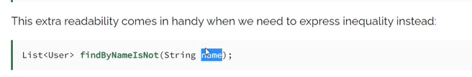

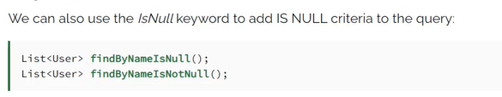

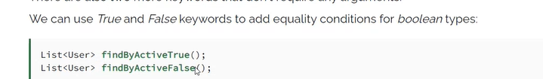

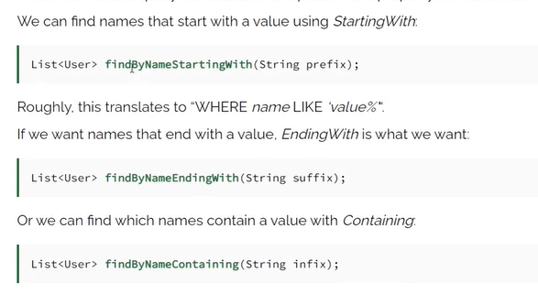

### Important

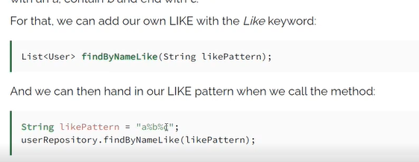

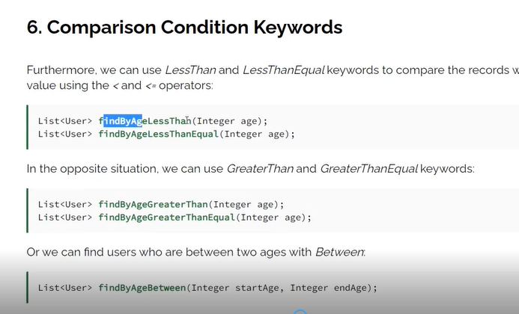

## Query methods

We write the query and run that

We have to pass two things -> our query and if its a native query or not

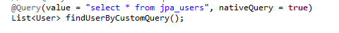

this way where nativeQuery = true, dependent on a particular db, tightly coupled

So its not necessary to write native queries

We can use these queries -> they r the same

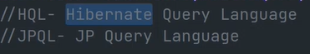

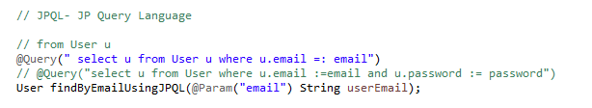



**This “email” is the dynamic property i.e it will come from what we pass in the parameter**

Dont think about the table instead think about your entity

### Google about - jpql query about diff ways to write query

We can simply do this

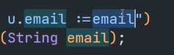

But if we want to name the parameter we r passing differently then to map both we use

@param

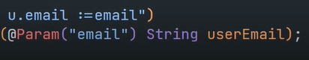

Also the method name could be anything starting with findBy unlike custom finder methods

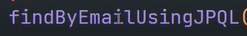

### Inside usersesrvicejpaimpl

We can impl the search by keyword method using the custom finder method

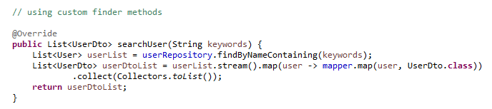

### Inside usercontroller

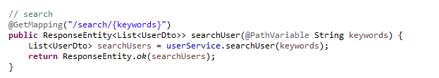

## Implementing category

## Assign -Left - > validation of category and product entity

# 28th nov

## Implementing product

# 29th nov

## Mapping types

One to one

One to many

Many to many

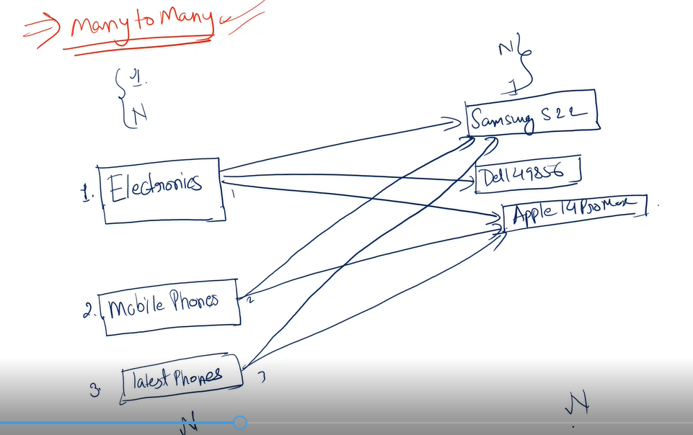

Here category - product is in one to many

One categor consists of many products

Unidirectional & bidirectional

2 ways to do mapping ->

1. Directly in db
2. In hibernate

## Linking product and category

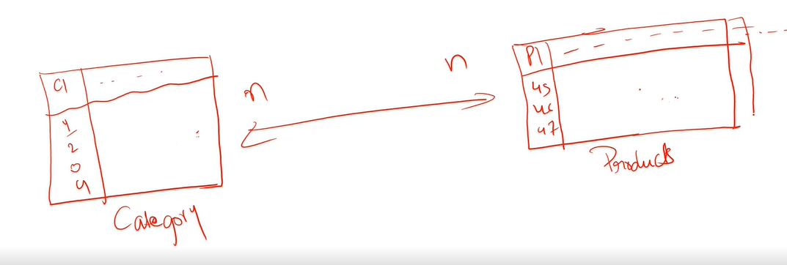

So if we put foreign key that is cid in products table then we wont be able to achieve many to many, it would be one to many ( a product can belong to only one category and many products to one category )

For this we have to create a new table - to implement our many to many relation

This is called join table -> it would have cid and pid

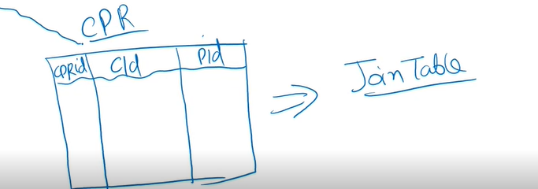

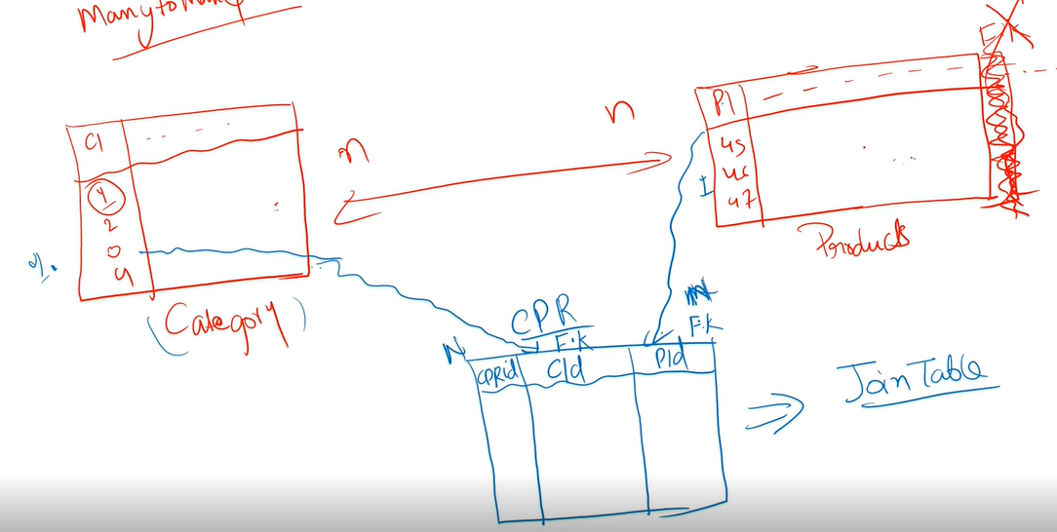

So basically we have one to many relation btw category table and join table and one to many for product table and join table.

## Code -> one to many



This will make it one to one - as we will be able to put one product for one category

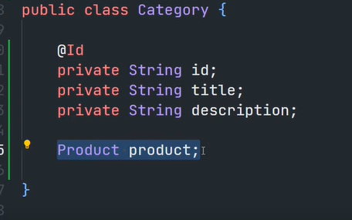

So we will make a list of products



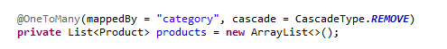

It made the join table on its own

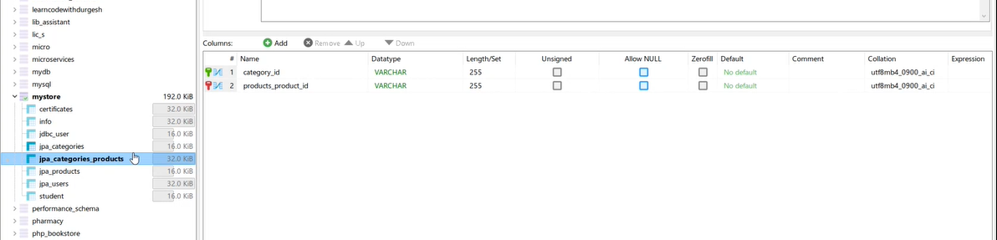

But here as we r not doing many to many we dont really need this extra table

To map the foreign key in the existing table

Right now what we have build is an unidirectional relationship

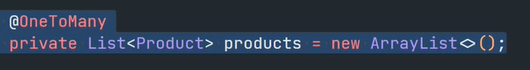

Basically we can get all products from its category but not vise versa

To make it bidirectional -> get category from product

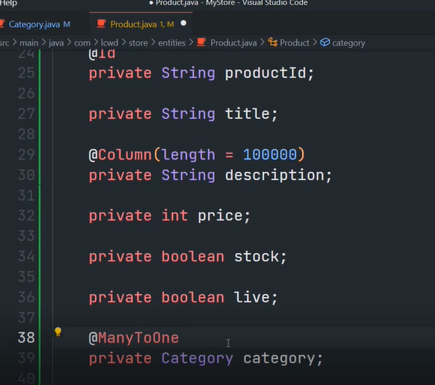

Here we dont need a list of category

To amange this bidirectional relationship ->

1. Adding foriegn key to products table

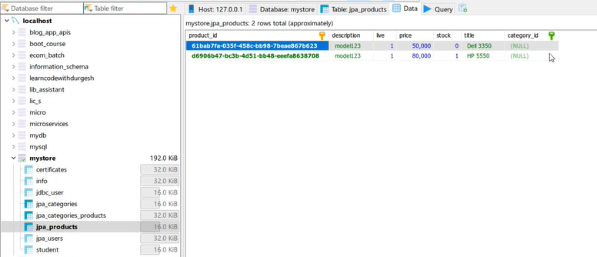

1. Making a new table to map



But we dont need two things

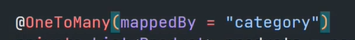

This will make it that to manage this relationship use this varaiable only

Now it woukdnt create that new table

CASCADE in SQL is **used to simultaneously delete or update an entry from both the child and parent table**.

Fetch type ->

When we want to fetch data of child

Here

Parent - category

Child - product

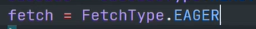

What it does is -> when u get parent it will also give u the child

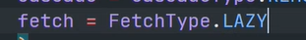

It wouldnt come in this

By default its lazy

We can also do this in product

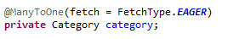

So when we access product it will give its category

### Step 2 -> make an api

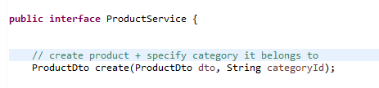

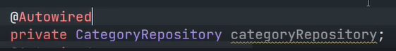

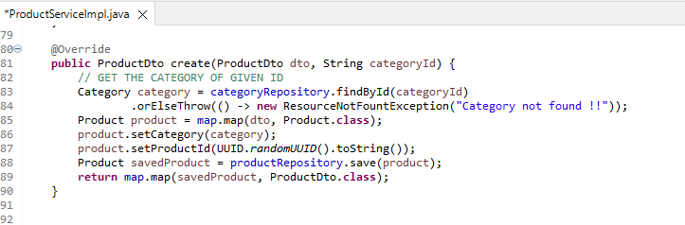

So now we can use either of the controllers - product or category

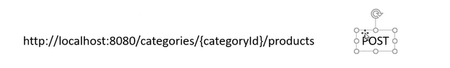

Inside category controlle r

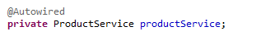

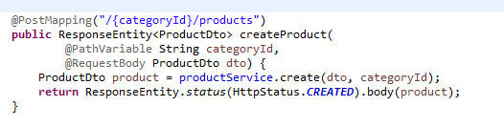

## Left - Assign -> many to many, url for update - category for product

## 

Take this product in this category

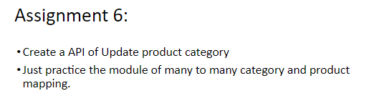

# 1st dec

## Cart Item & Order Item concept

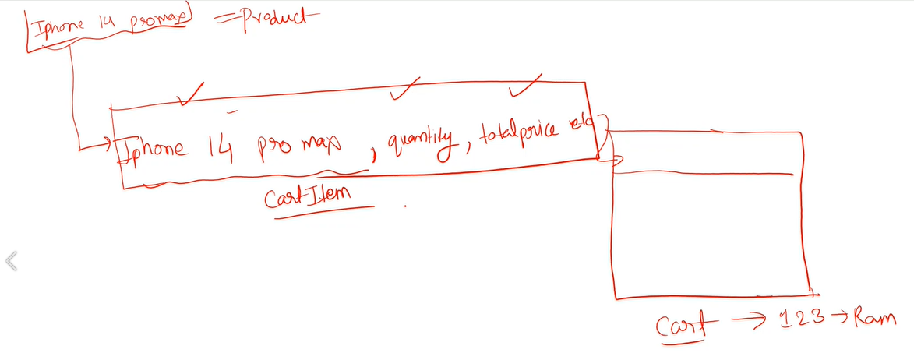

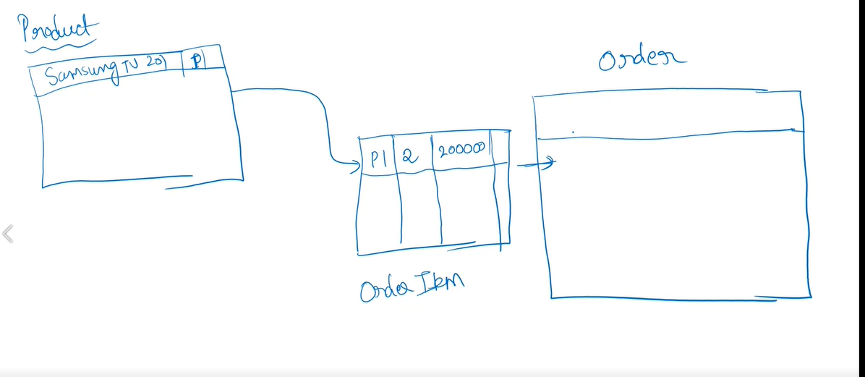

## Cart

1. Cart entity & dto

2. Cart item entity & dto

3. Cart repository & cartitem repository

4. CartItemRequest

5. Cart service and impl

6. Cart controller

## Left - Assign - in cartcontroller , cartserviceimpl

// TODO: remove item from cart

// TODO: Clear cart

# 2nd dec

## Implementing order and order item

1. order entity & dto

2. order item entity & dto

3. oder repository & oderitem repository

4. CreateOrderRequest - IN ORDER TO ACCEPT THE DATA USER SENDS IN JSON

Here basically we take in the cart id as we know its the items in the cart that will be order item

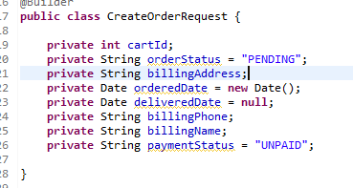

5. Cart service and impl

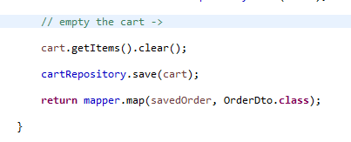

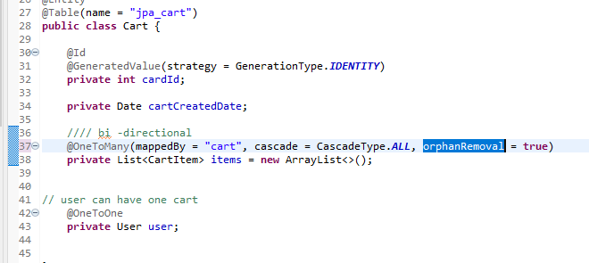

6. Cart controller

## Left -Assign

@Override

public void deleteOrder(String orderId) {

// TODO Auto-generated method stub

// change the status no need to delete the order from db

}

@Override

public List<OrderDto> getOrdersOfUser(String userId) {

// TODO Auto-generated method stub

return null;

}

@Override

public List<OrderDto> getOrders() {

// TODO Auto-generated method stub

return null;

}

# 5th dec - no rec

Pagination

## Left

# 6th dec

## Spring security

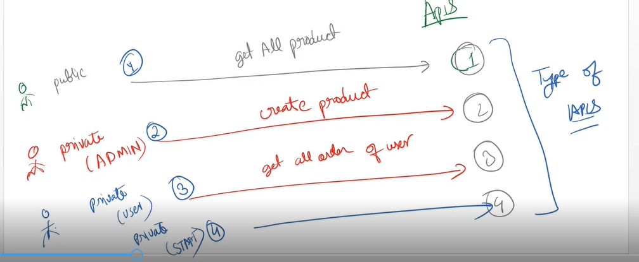

## Authorization vs authorization

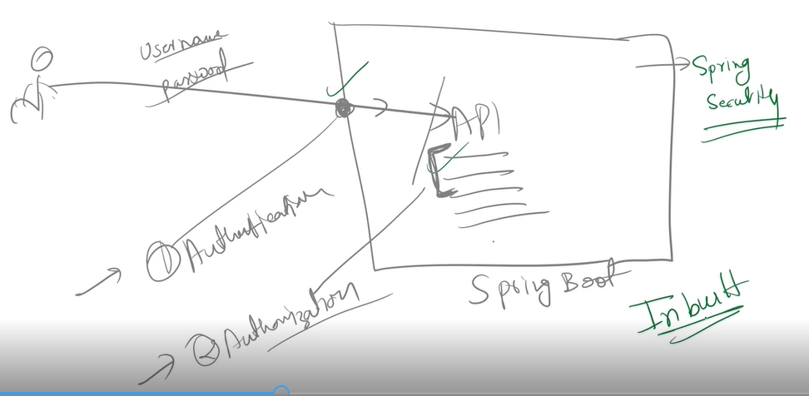

Only need to do configuration

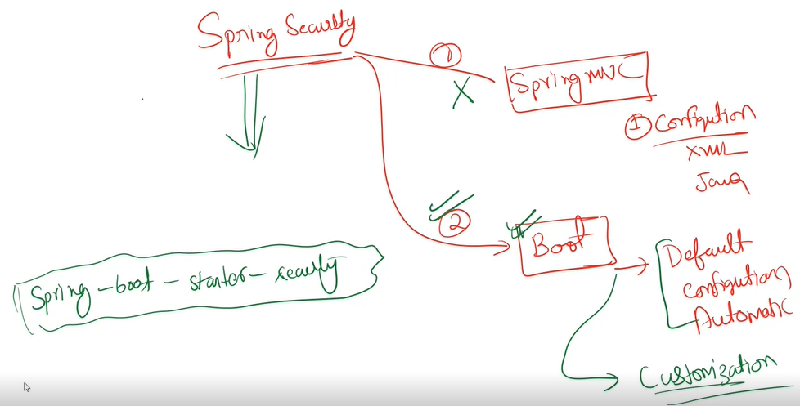

## Spring booy starter security

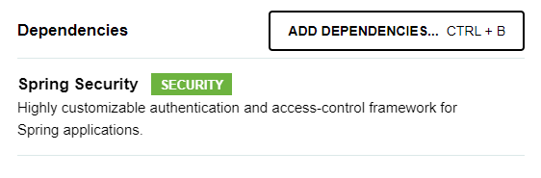

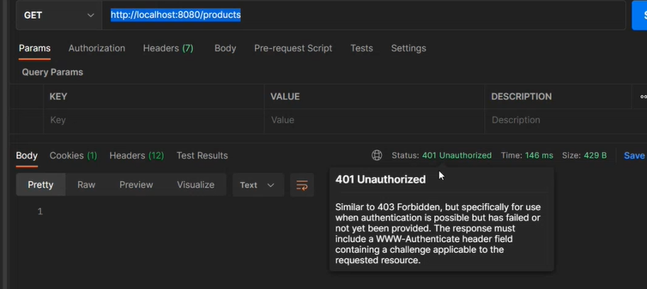

Now every api is protected and cannot be accessed by everyone

It provides a form based security which is provide if we access it in web browser

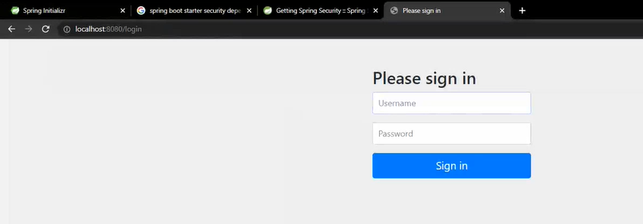

It has created by default username and password

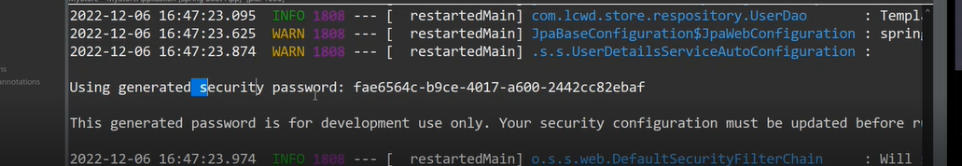

Username -> user

Now we access all the apis

We can also logout

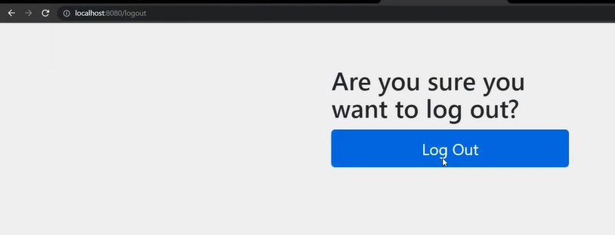

## Customize username and password

### WAY 1 ->

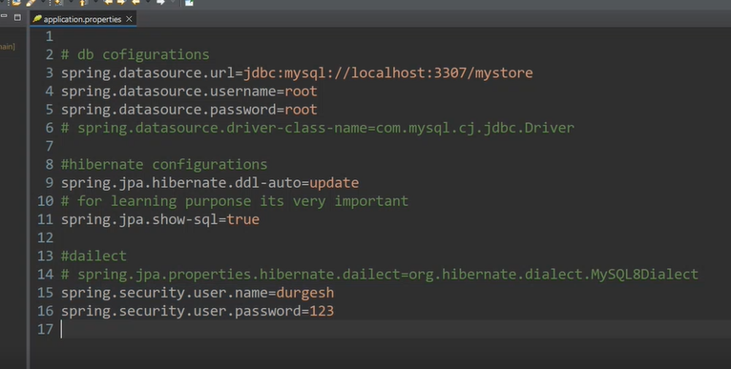

### WAY 2 ->

CONFIGURATION CLASS

So this is okay when we have form based security

But usually we dont use this application directly on web and will be used by some front end application -> then we dont need this form based authentication

Step 1-> make a config file

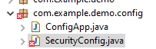

Step 2->

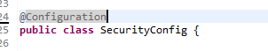

Declare a bean -> SecurityFilterChain

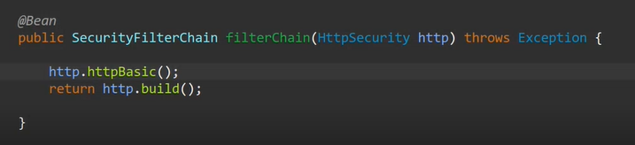

http.httpBasic is the type of build or mechanism we need

Calling this method on HttpSecurity will enable [Http Basic Authentication](https://en.wikipedia.org/wiki/Basic_access_authentication) for your application with some "reasonable" defaults.

It will return a [HttpBasicConfigurer](https://docs.spring.io/spring-security/site/docs/4.2.12.RELEASE/apidocs/org/springframework/security/config/annotation/web/configurers/HttpBasicConfigurer.html) for further customization.

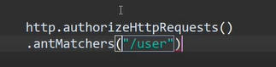

Ths will authorize request that comes from /user url

Or authenticate and authorize any request and use http basic mechanism to build

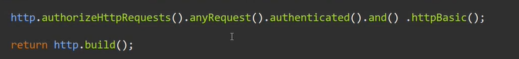

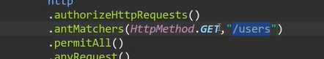

This would make the get method of users will be public

Step 3-> enable web security

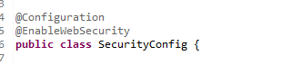

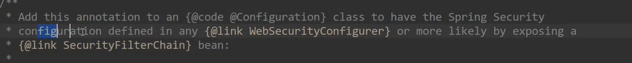

Now the form comes in diff way

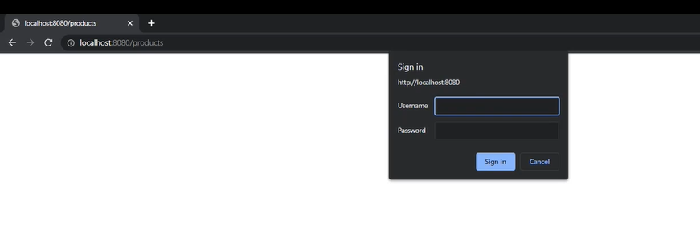

It isnt a html form

It is being made with the help of javascript

Now we have changed our form based authentication to http basic authentication with the help of javascript

So now we dont need a web browser

We can even access it in postman

Change your authorization type to basic authorization

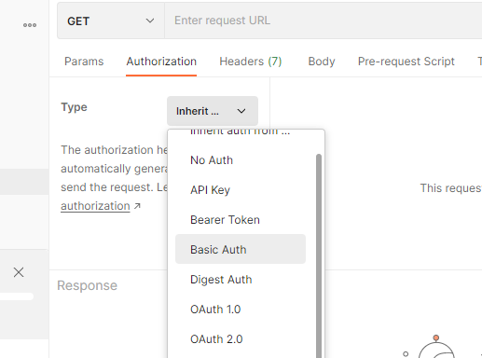

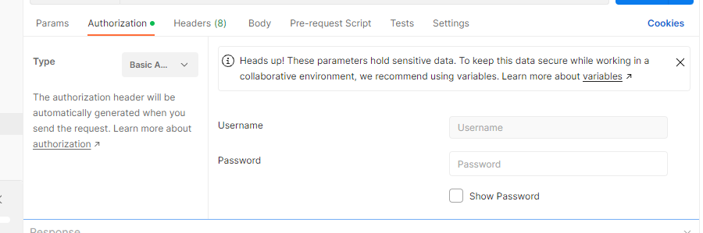

Basic authentication disadvantage -> for every request send username and password

Step 4-> user

So we dont want to specify the user like this

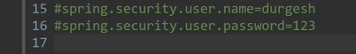

To configure user

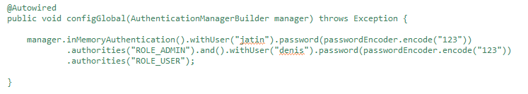

Create a bean for password encoder

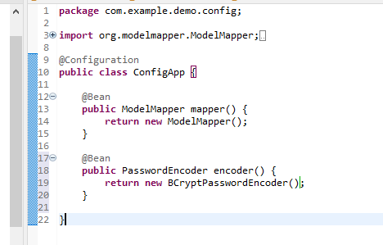

To put the encode password in db 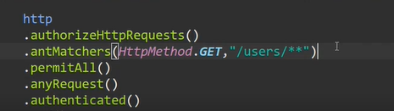

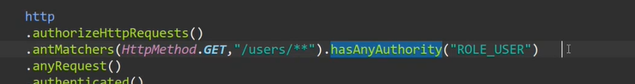

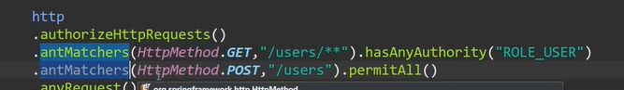

BAICALLY ONLY TWO METHODS WE HAVE TO MAKE

1. TO CONFIGURE HTTP REQUEST
2. FOR USER ROLE

# 7th dec

## JWT Token

To access data -> to need token

…. In diary

## Implementation

Step 1 -> add dependency

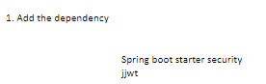

Step 2 ->

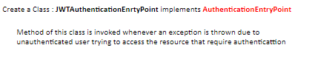

Step 3 ->

Security package



;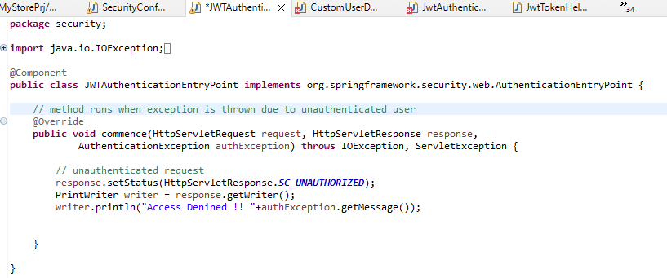

Step 4 ->

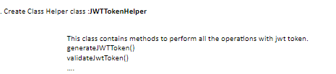

Step 5 ->





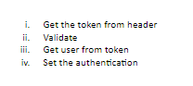

1.

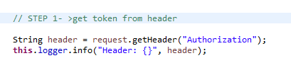

This authorization is actually in the header, so it takes this value

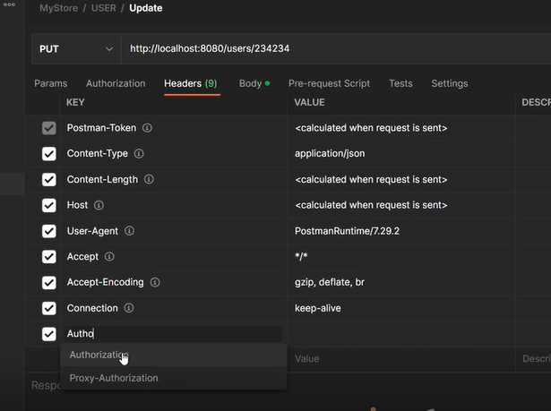

2.

Header might contain a lot of things so we have to these things

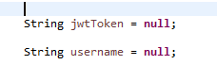

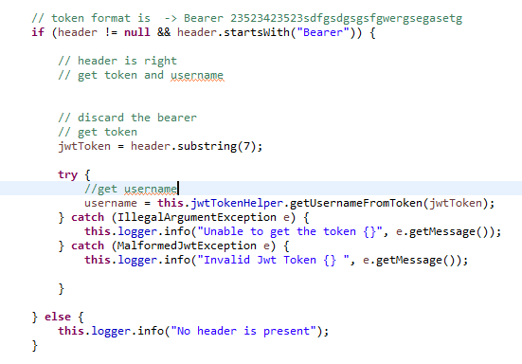

1. get user and validation

SecurityContextHolder.getContext().getAuthentication() must be null that is security shouldnt already know

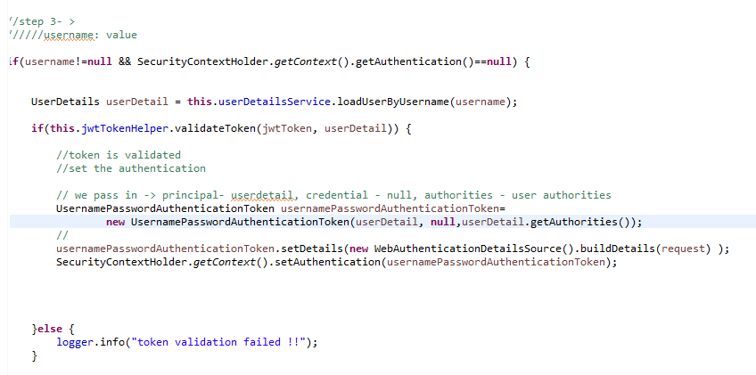

1. forward the request after filtering

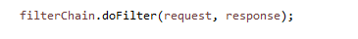

Step 6 ->



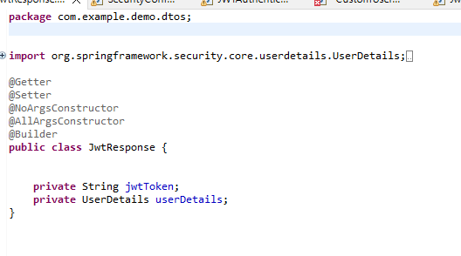

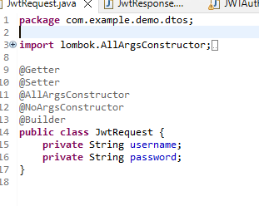

Step 7 ->

Configure jwt in spring security

We want to authentiacte users from our database ->

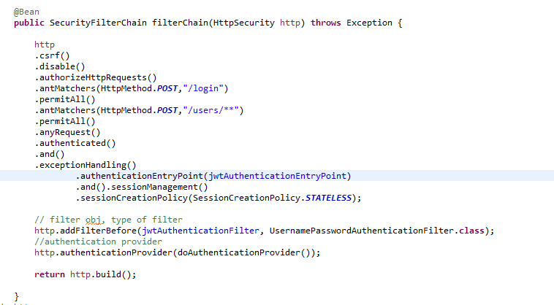

We need to make a authentication provider



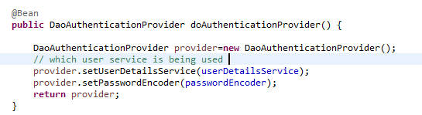

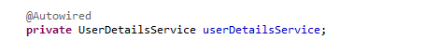

We will provide this interface method implementation in ->

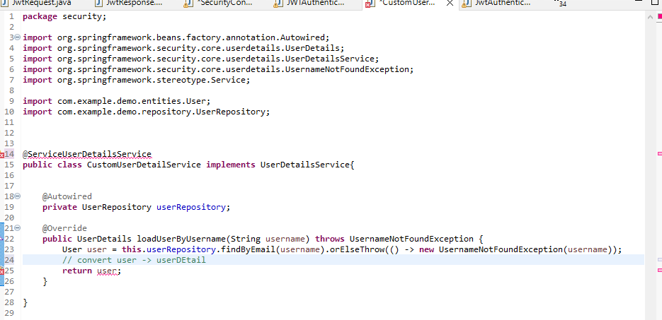

To convert that we will



And add unimplemented methods

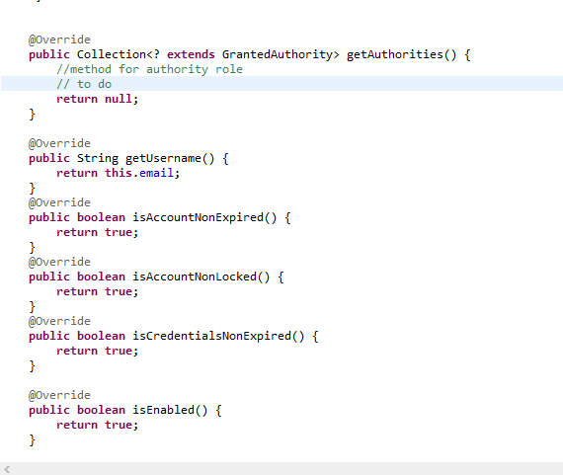

## Step 8 -> to generate token api

Inside user controller

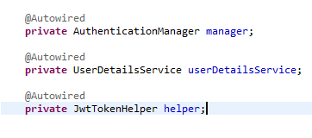

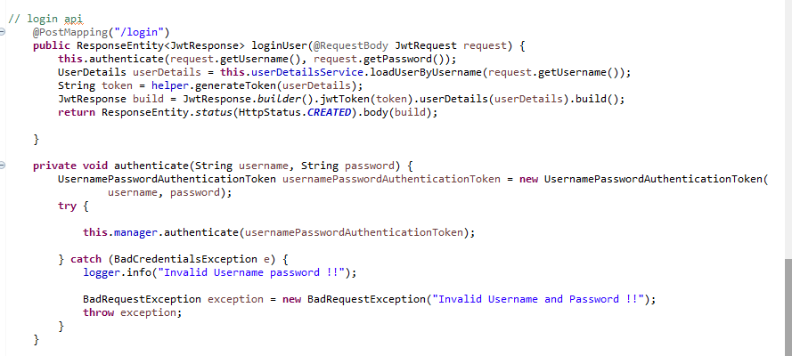

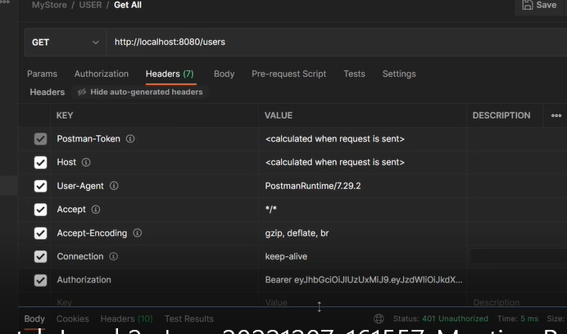

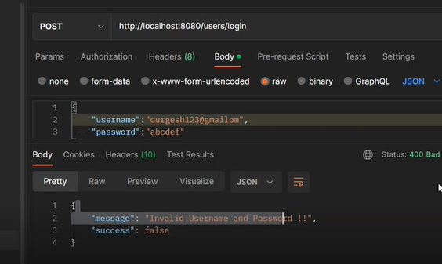

## Left

# 9th dec

## Deploying spring boot on aws - video - yt

## Interface

People on front end wont need to go through backend code of spring to know what apis are there

Need interface

We create a documentation -> tool - swagger

## Steps



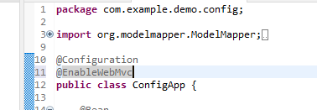

This provides a url but its not public yet

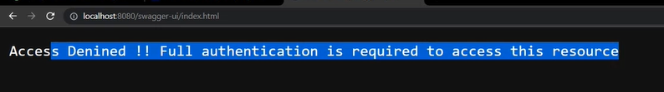

To make it public

Inside securityConfig

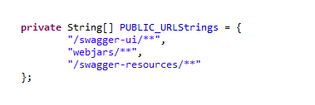

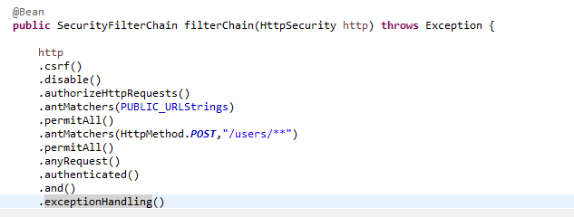

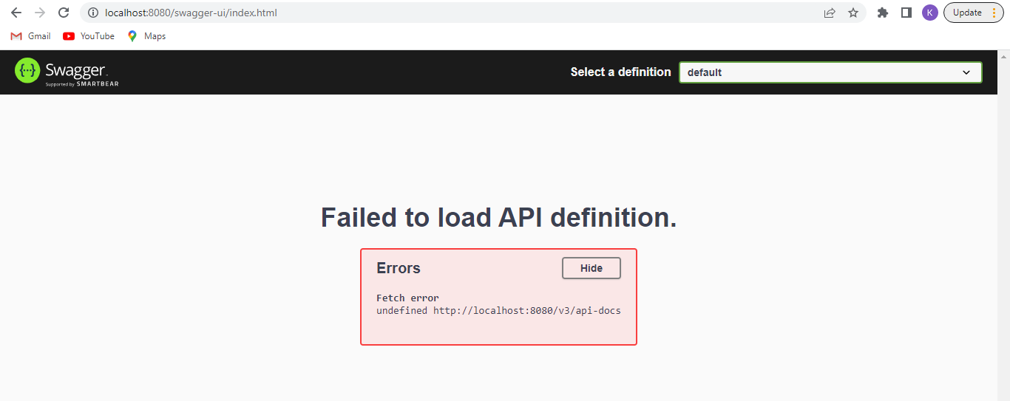

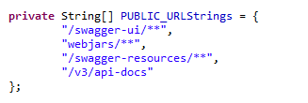

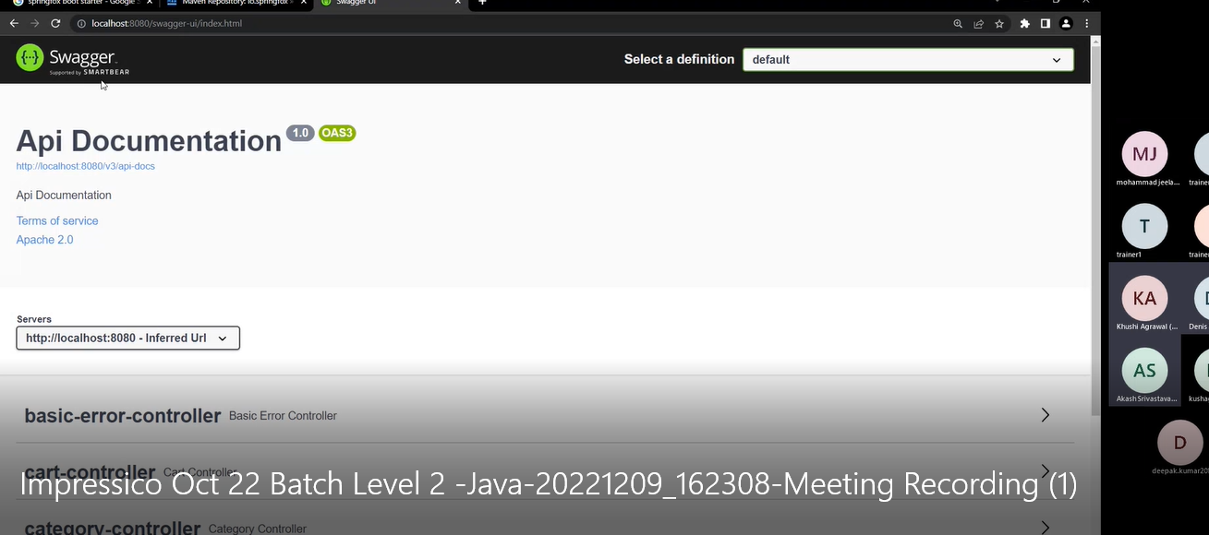

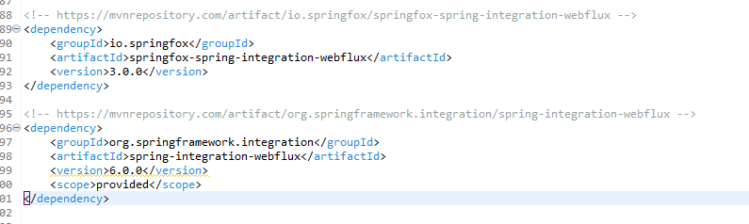

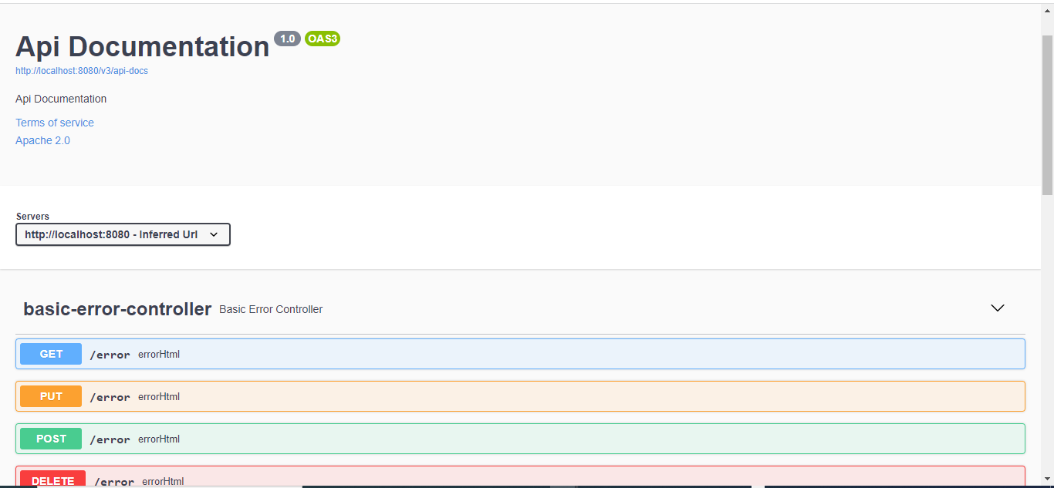

We can test our api from here only

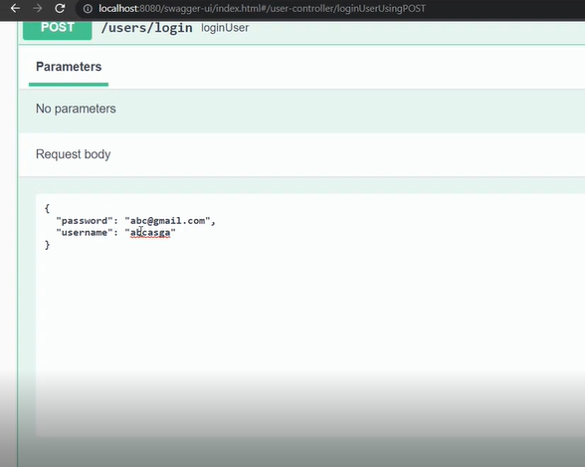

## Prb -> cant login due to authentication and hence cant access every api

Swagger config

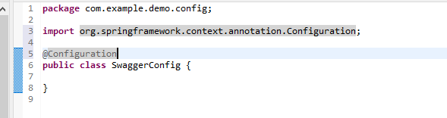

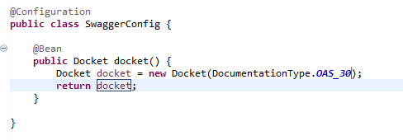

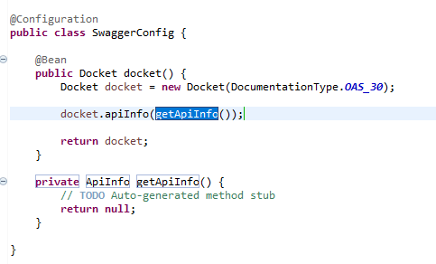

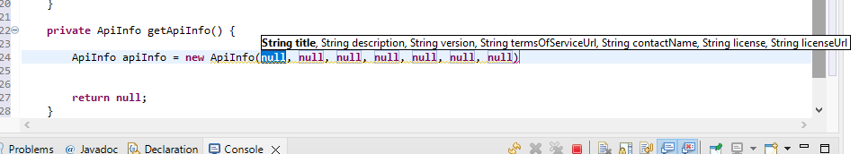

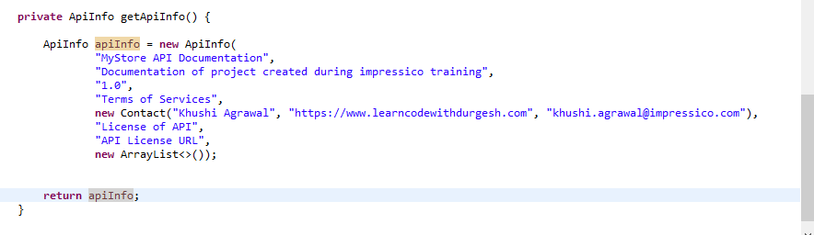

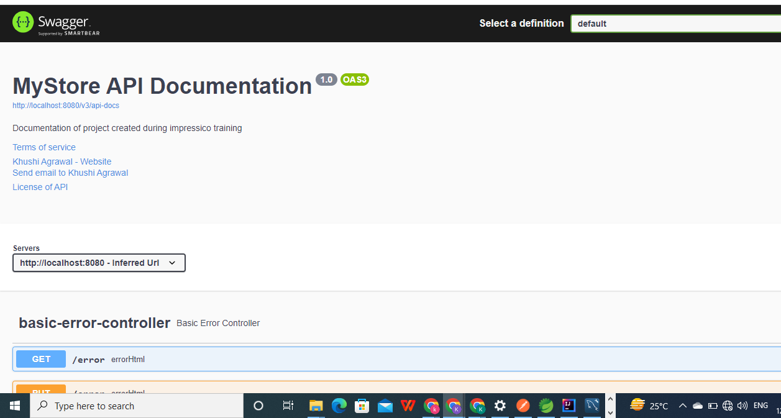

## 5. Configure spring security in swagger

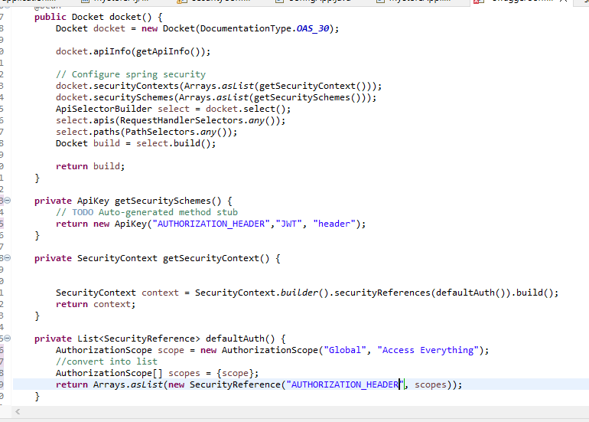

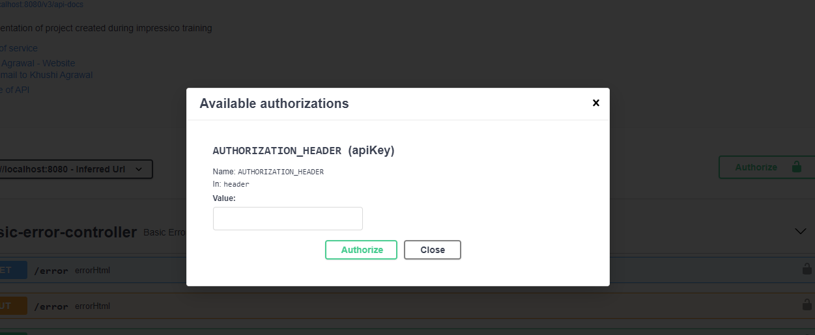

## 6. TESTING IT

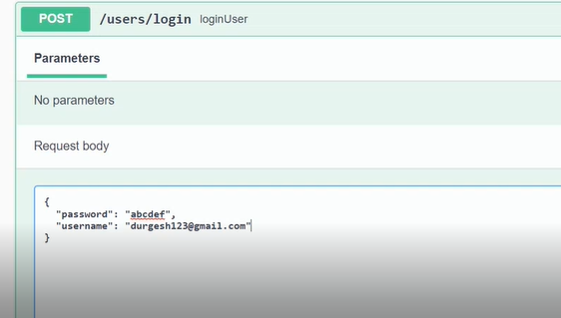

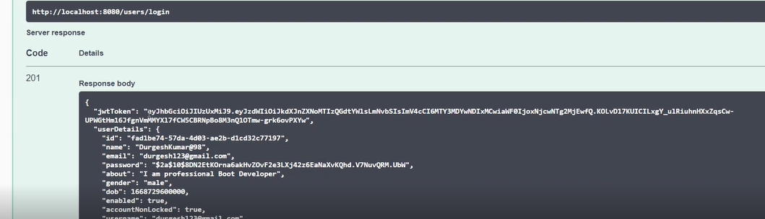

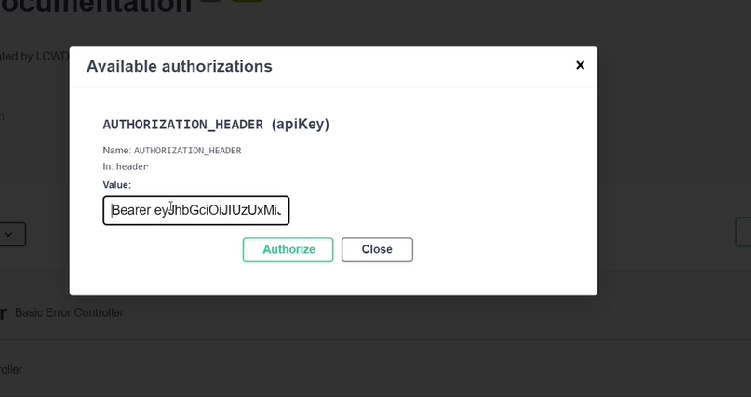

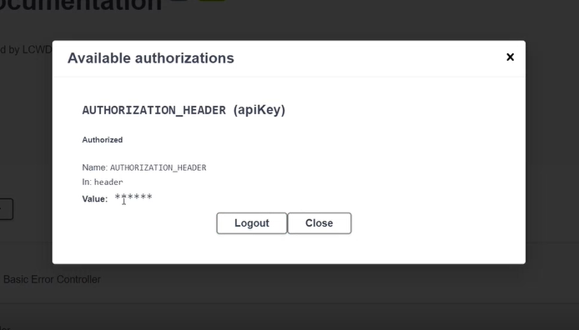

# 12th dec

## ROLE MANAGEMENT

## Store role of user in db

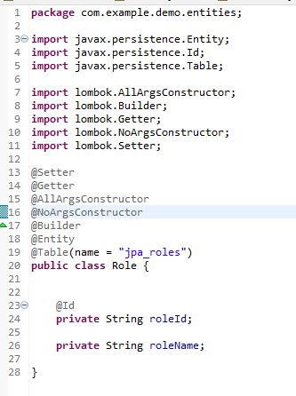

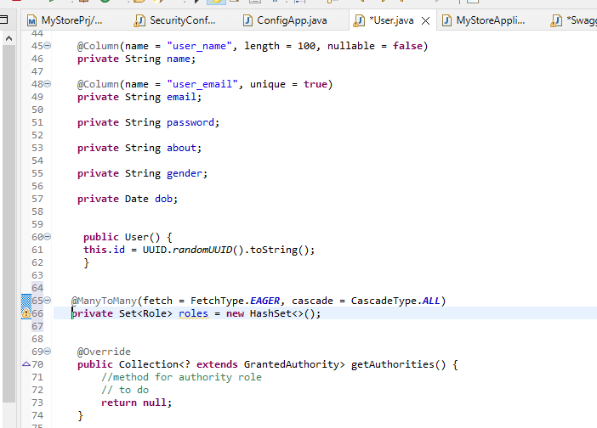

Unidirectional

Repo

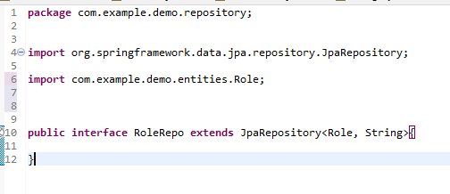

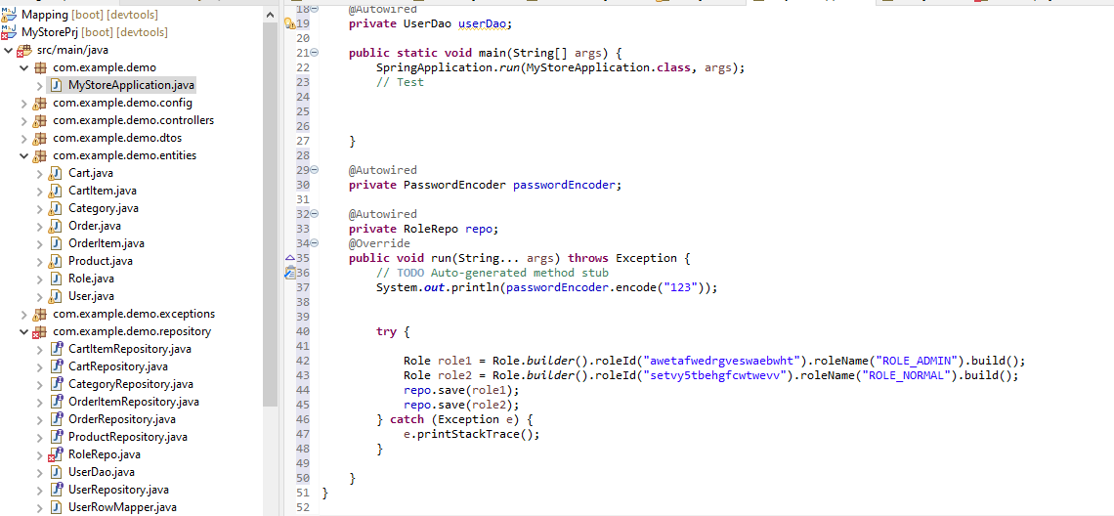

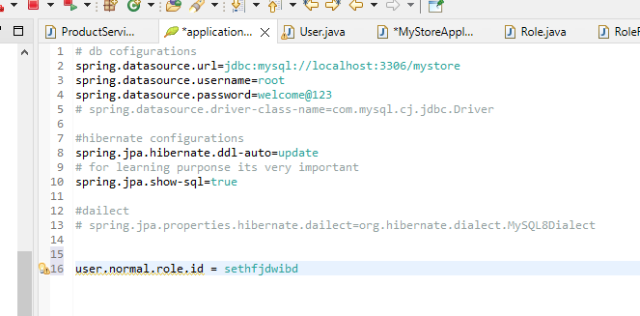

When we fetch user -> need to know role

Send role with user

Roledto

Use roledto in userdto

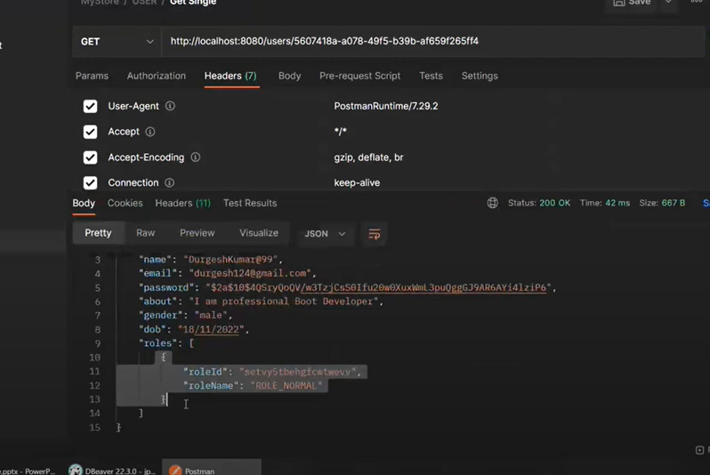

Sign up -> normal user

## 3. Use roles to access apis

In user entity

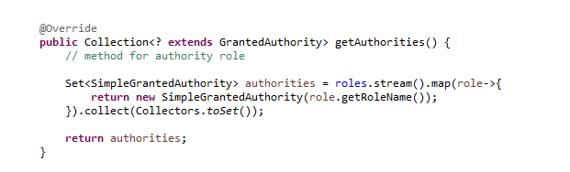

### Way 1 ->

Certain pattern url - access by only admin

In security config

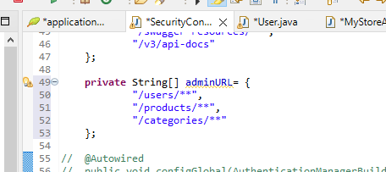

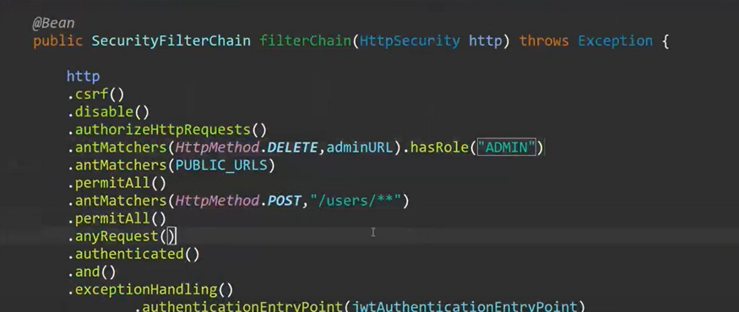

Or

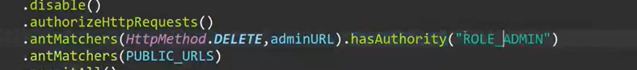

Now only admin can the delete functions of the admi urls can be done by admin only

## WAY 2 ->

PUT SECURITY ON A METHOD - I.E PARTICULAR API

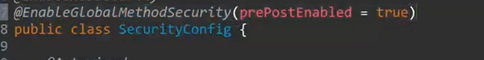

Eg -> product update can be done by only admin

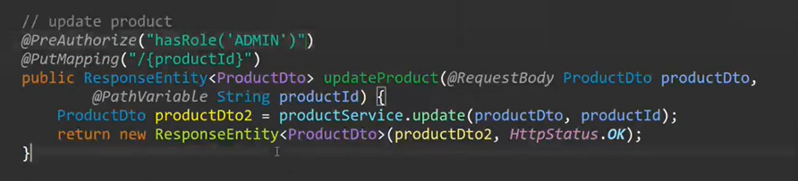

Only admin can create product

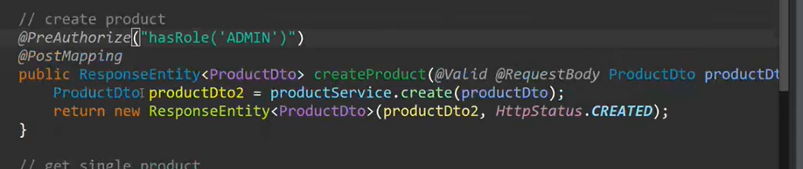

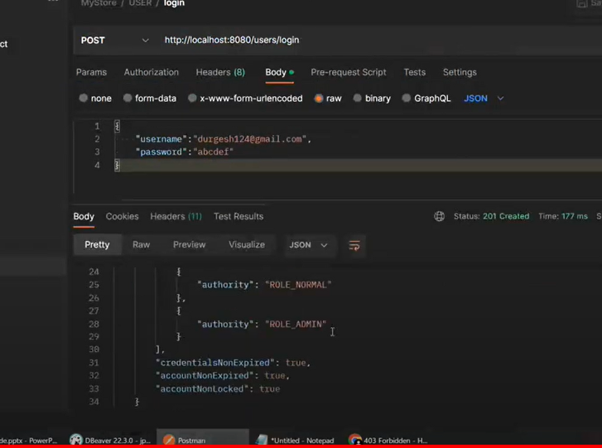

## 13TH DEC

## Pagination

Pagination is often helpful when we have a large dataset and we want to present it to the user in smaller chunks.

Also, we often need to sort that data by some criteria while paging

10 K records - 10 pages - each page 1k records - only render that many

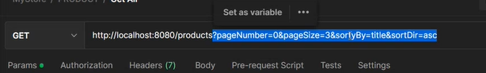

So we need to fetch these in the controller

In productController

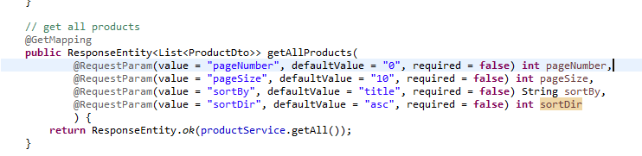

Not really suggested to keep the hard coded values directly

So we will make a new file ->

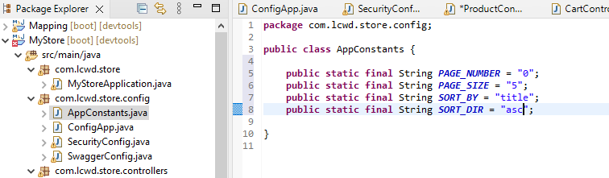

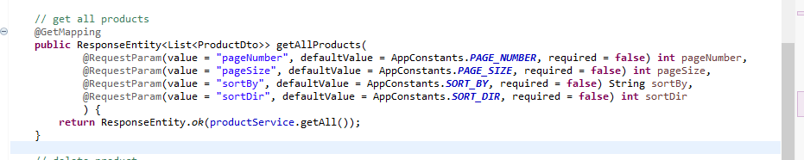

We will pass thwm in the service

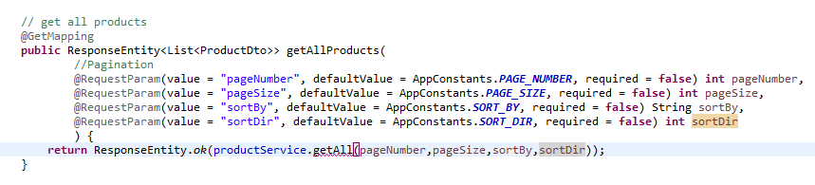

In product service



We have a finall method that takes in sort

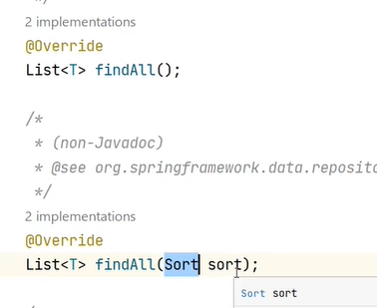

And also this

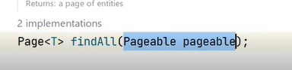

But we need to pass both so when we pass in pagable then we will also pass in the sort

In productServiceImpl

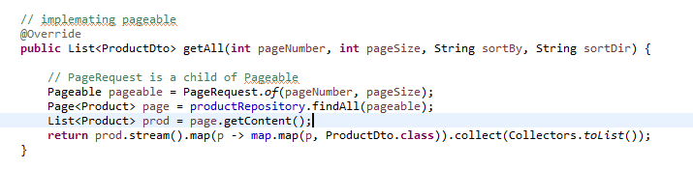

So till now we have implementation only pagination and not sorting

So it will return the list of products for that page

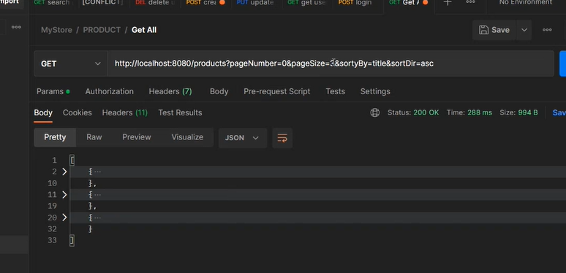

Start pages from 1

Implemeting sorting

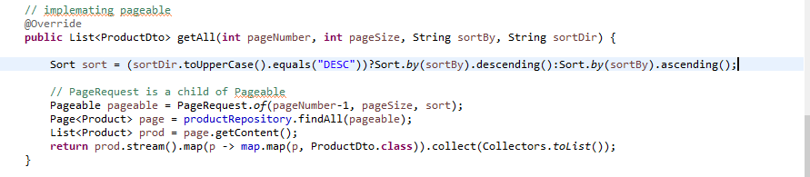

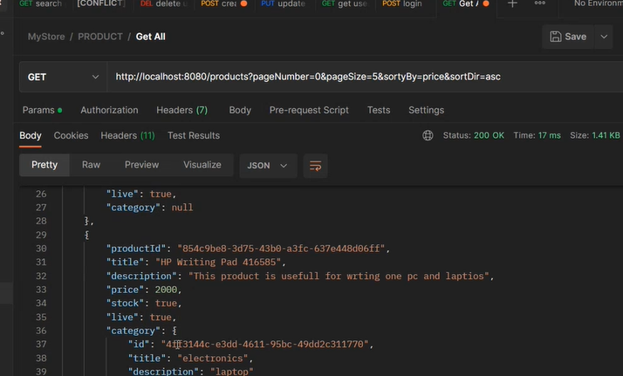

We need info on how amny pages, is it the last page etc

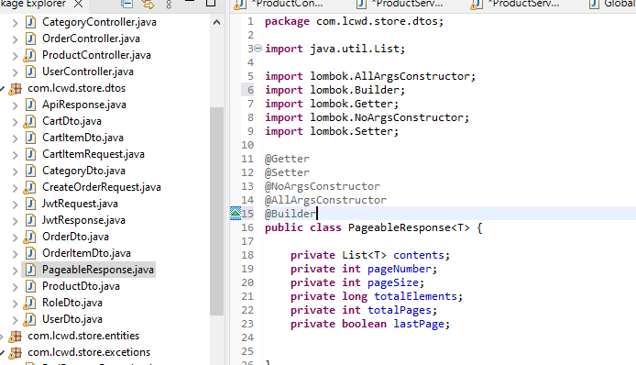

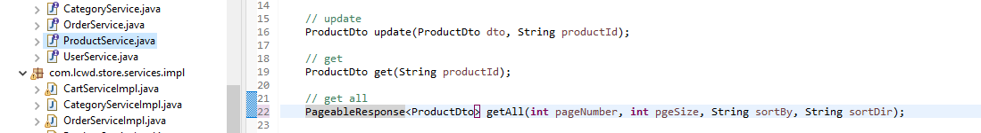

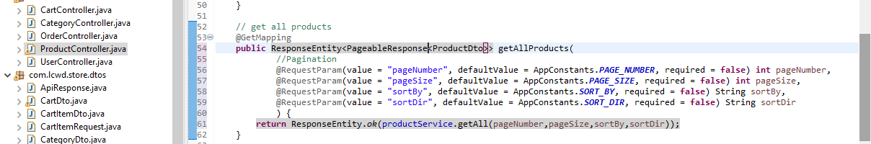

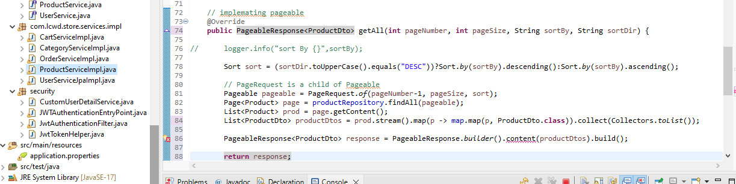

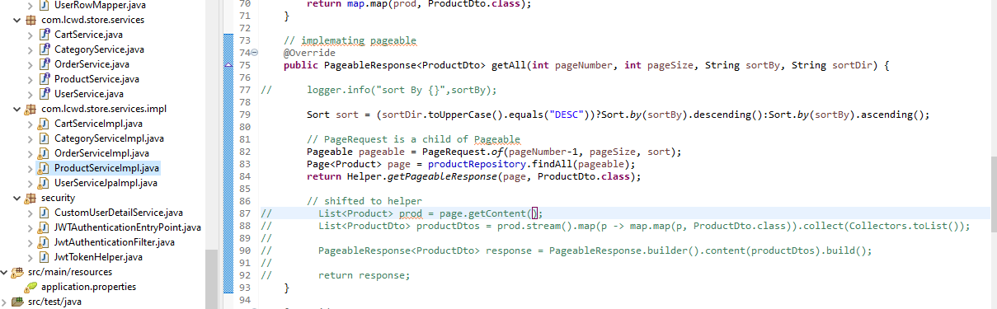

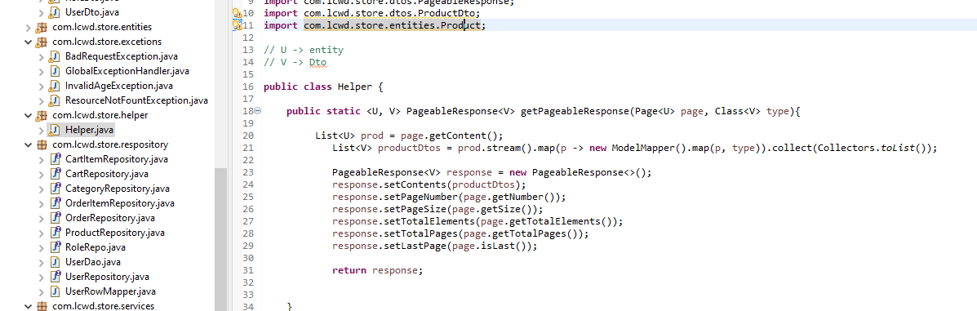

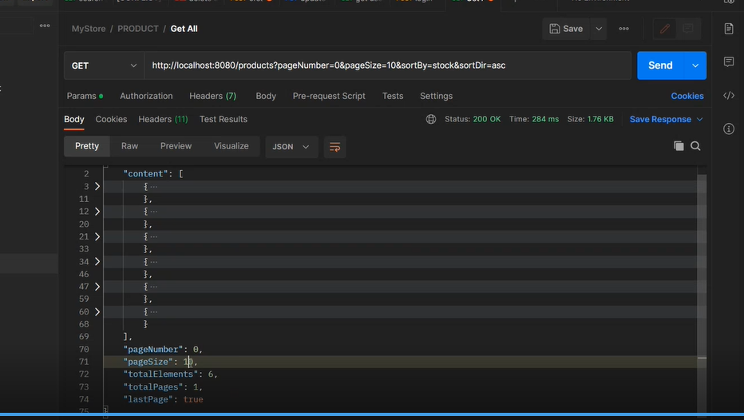

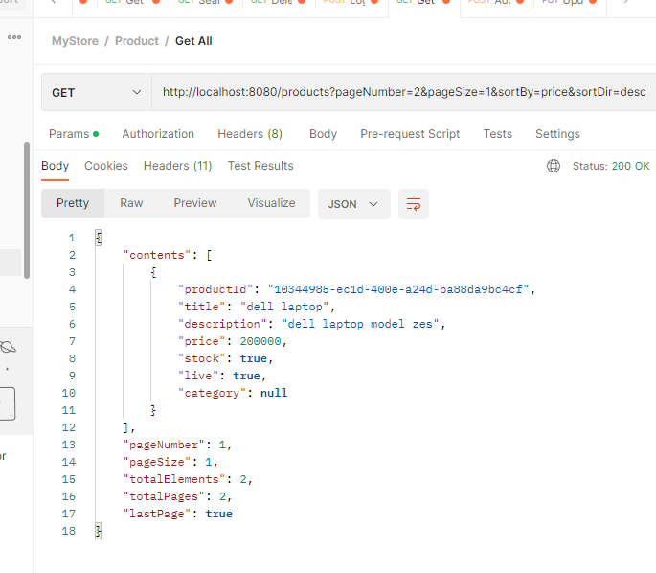

# Final outputs ->

## Getting started

Made a user

Made a role

Entered the user as admin in user_role table

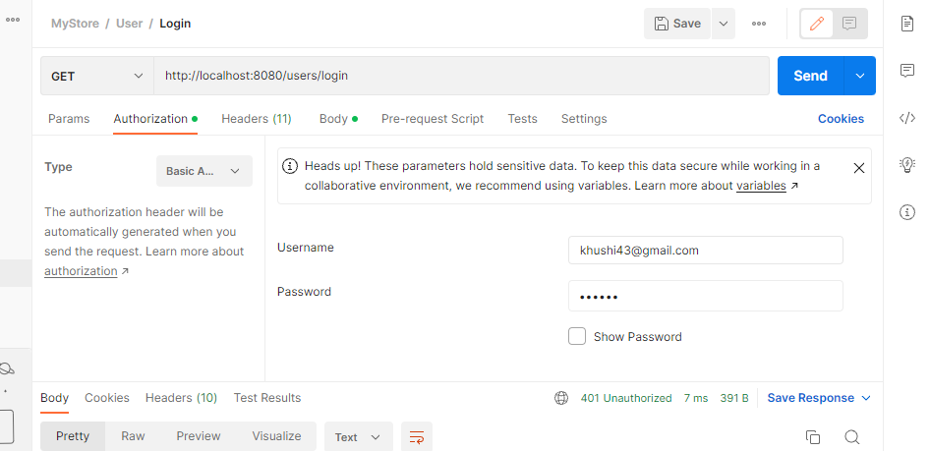

We r using email as our username in login

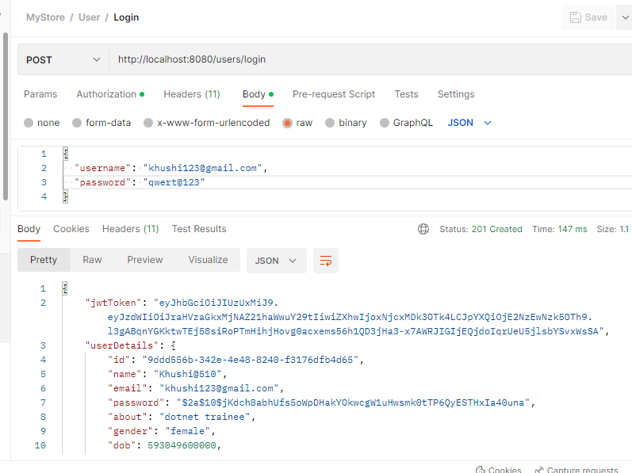

## Left

